Style Guidelines for Final Year Project ReportsInfluence Harbor

Final Year Project – Mid Report

Session 2021-2025

A 4th Year Student
A project submitted in partial fulfilment of the
COMSATS University Degree
of
BSc. (Hons.)BS in Computer Science / Software Engineering (CUI)



Department of Computer Science
COMSATS University Islamabad, Lahore Campus
12 May 2024

Project Detail
Type (Nature of project) |  |  | [ ✔ ] Development [ ] Research [ ] R&D
Area of specialization
Project Group Members
Sr.# | Reg. # | Student Name |  | Email ID | *Signature
(i) | SP21-BSE-019 | Ali Saif |  | sp21-bse-019@cuilahore.edu.pk
(ii) | SP21-BSE-033 | Rizwan Sabir |  | sp21-bse-033@cuilahore.edu.pk
(iii) | SP21-BSE-057 | - Hanzla MIrza |  | sp21-bse-057@cuilahore.edu.pk

*The candidates confirm that the work submitted is their own and appropriate credit has been given where reference has been made to work of others

Plagiarism Free Certificate
This is to certify that, I am ________________________ S/D/o _______________________, group leader of FYP under registration no CIIT/_________________/LHR at Computer Science Department, COMSATS University Islamabad, Lahore Campus. I declare that my FYP report is checked by my supervisor and the similarity index is ________% that is less than 20%, an acceptable limit by HEC. Report is attached herewith as Appendix A.
Date: ____________ Name of Group Leader: ________________________ Signature: _____________

Name of Supervisor: _____________________ Co-Supervisor (if any):____________________
Designation: _____________________ Designation: _____________________
Signature: _____________________ Signature: _____________________

Abstract
Influence Harbor encompasses letting the different social media communities and business-persons work together by providing solid interest based outcomes. It provides opportunities for the brands to find the best suited social media personalities for their campaigns. Influence Harbor gives its community a competitive advantage by providing interest based information regarding fashion. The groups and blog pages provide the users with relevant information about the brands and professional reviews letting the users decide what will be suitable for their specific needs. The brand groups will enhance the audience retention by updating its audience about the upcoming events and articles and disperse the information to the target audience more effectively and efficiently. The users will have early access to information from their favorite brands that will benefit both communities. The social media figures can get benefited by earning contracts from brands of their interested niche and can maximize their potential with minimum efforts. Influence Harbor is equipped with the ability to short-list the influencers for the brands on the basis of their required inputs.

Acknowledgement
It is optional

Table of Contents
1. Project Introduction 14
1.1. Introduction 14
1.2. Objectives 15
1.3. Problem statement 16
1.4. Assumptions & constraints 16
1.5. Project scope 17
2. Requirements Analysis 17
2.1. Existing systems: 17
2.2. Stakeholders list (Actors)Requirements elicitation: 17
2.2.2. Brand: 18
2.2.4. General User (Audience): 18
2.3. Functional Requirements 18
2.4. Non-functional requirements 20
2.4.2. Usability: 21
2.4.4. Integrity: 21
2.4.7. Maintainability: 21
2.4.9. Flexibility: 21
2.4.10. Security: 22
2.5. Requirements traceability matric 22
2.6. Use case descriptions 25
2.7. Use case design: 41
2.8. Use case design Software development life cycle model (justification on why this particular model is considered) 69
2.8.1. Agile Development Model 69
2.8.1.1. Flexibility and Adaptability: 69
2.8.1.2. Continuous Feedback and Collaboration: 70
2.8.1.3. Early Delivery and Incremental Progress: 70
2.8.1.4. Focus on User Stories and Customer Value: 70
2.8.1.5. Reduced Risk and Improved Quality: 70
3. Chapter 3: System Design 71
3.1. Work breakdown structure (WBS) 71
3.2. Activity diagram 72
3.3. Sequence diagram 102
3.4. Software architecture 126
3.5. Database diagram 127
3.6. Network diagram (Gantt chart) 128
3.7. Class Diagram 130
3.8. Collaboration Diagram 131
4. Chapter 4: System Testing 131
4.1. Test cases: 131
4.2. Unit Testing: 139
4.3. Integration Testing: 139
4.4. Acceptance Testing: 139
5. Chapter 5: Conclusion 139
5.1. Problems faced and lessons learned: 139
5.2. Project summary: 140
5.3. Future work: 140
6. References: 140
Appendix A 141
Include here the 1st page of Turnitin Report 141

List of Tables
Table 1 Functional Requirement of Business/Brand 17
Table 2 Functional Requirement of Professional 18
Table 3 Functional Requirement of Help Desk 18
Table 4 Functional Requirement of Audience 18
Table 5 Requirements traceability matric of Business/Brand 21
Table 6 Requirements traceability matric of Professional 22
Table 7 Requirements traceability matric of Help Desk 23
Table 8 Requirements traceability matric of Audience 23
Table 9 Use-case <Sign Up> 24
Table 10 Use-case <Login and logout> 24
Table 11 Use-case <Create group> 25
Table 12 Use-case <Add Post/ Event> 25
Table 13 Use-case <Hire Influencer> 25
Table 14 Use-case <Delete/ modify Post/Announcement> 26
Table 15 Use-case <Offer Contract> 26
Table 16 Use-case<Approve Contract> 27
Table 17 Use-case <Cancel/ modify contract> 27
Table 18 Use-case <Add payment method> 28
Table 19 Use-case <View Analytics> 29
Table 20 Use-case<View ongoing contracts/ submit deliverables> 29
Table 21 Use-case <Delete/ Modify Profile> 30
Table 22 Use-case <View/ rate contract> 30
Table 23 Use-case<Add payment withdrawal method> 31
Table 24 Use-case <Withdraw amount> 32
Table 25 Use-case<Contact Help Desk> 32
Table 26 Use-case <View Queries> 33
Table 27 Use-case <Contact query parties> 33
Table 28 Use-case<Modify query status> 34
Table 29 Use-case <Respond to Query> 34
Table 30 Use-case<Follow business page> 35
Table 31 Use-case<Join group> 36
Table 32 Use-case <Interact with post> 36
Table 33 Use-case <Modify/ Delete interaction> 37
Table 34 Use-case <Approve request delete account> 38
Table 35 Use-case<Search> 38
Table 36 Test case<Sign Up> 128
Table 37 Test case <Login> 129
Table 38 Test case<Add post> 129
Table 39 Test case<Modify post> 130
Table 40 Test case<offer contract> 130
Table 41 Test case <modify contract> 131
Table 42 Test case <Add payment method> 132
Table 43 Test case <submit deliverables> 132
Table 44 Test case<Modify profile> 133
Table 45 Test case<rate contract> 133
Table 46 Test case <withdraw amount> 134
Table 47 Test case<modify query status> 134
Table 48 Test case <respond to query> 135
Table 49 Test case<Interact with post> 135
Table 50 Test case<Modify interaction> 136

List of Figures
Figure 1. Use-case diagram <sign up> 39
Figure 2. Use-case diagram <Login and logout> 40
Figure 3. Use-case diagram <Create group> 41
Figure 4. Use-case diagram <Add Post/Event> 42
Figure 5. Use-case diagram <Delete/ modify post/event> 43
Figure 6. Use-case diagram <Hire professional> 44
Figure 7. Use-case diagram <offer contract> 45
Figure 8. Use-case diagram <Cancel/ modify contract> 46
Figure 9. Use-case diagram <Approve contract> 47
Figure 10. Use-case diagram <Add payment method> 48
Figure 11. Use-case diagram <View Analytics> 49
Figure 12. Use-case diagram <View ongoing contracts/ submit deliverable> 50
Figure 13. Use-case diagram<delete/modify profile> 51
Figure 14. Use-case diagram <view/rate contract> 52
Figure 15. Use-case diagram<Add withdrawal method> 53
Figure 16. Use-case diagram <Withdraw amount> 54
Figure 17. Use-case diagram<Contact Help Desk> 55
Figure 18. Use-case diagram <View Queries> 56
Figure 19. Use-case diagram <Contact query parties> 57
Figure 20. Use-case diagram<Modify query status> 58
Figure 21. Use-case diagram<Respond to query> 59
Figure 22. Use-case diagram <Follow business page> 60
Figure 23. Use-case diagram<Join group> 62
Figure 24. Use-case diagram <Interact with post> 63
Figure 25. Use-case diagram <Modify/delete interaction> 64
Figure 26. Use-case diagram<Request delete account> 65
Figure 27. Use-case diagram<Search> 66
Figure 28. Work breakdown structure (WBS) 68
Figure 29. Activity diagram<Sign up> 69
Figure 30. Activity diagram<Login and logout> 70
Figure 31. Activity diagram <Create group> 71
Figure 32. Activity diagram<Add Post/Announcement> 73
Figure 33. Activity diagram <Delete/modify post> 74
Figure 34. Activity diagram <Hire Professional> 75
Figure 35. Activity diagram <Offer contract> 76
Figure 36. Activity diagram<cancel/modify contract> 77
Figure 37. Activity diagram <Approve contract> 78
Figure 38. Activity diagram<Add payment method> 80
Figure 39. Activity diagram<View Analytics> 81
Figure 40. Activity diagram<Submit deliverables> 82
Figure 41. Activity diagram <delete/ modify profile> 83
Figure 42. Activity diagram<rate contract> 84
Figure 43. Activity diagram<Add withdrawal method> 85
Figure 44. Activity diagram<Withdraw amount> 86
Figure 45. Activity diagram <Contact Help desk> 87
Figure 46. Activity diagram<View Queries> 88
Figure 47. Activity diagram <Contact query parties> 89
Figure 48. Activity diagram <Modify query status> 90
Figure 49. Activity diagram <Respond to query> 91
Figure 50. Activity diagram <Follow page> 92
Figure 51. Activity diagram<Join group> 93
Figure 52. Activity diagram <Interact with post> 95
Figure 53. Activity diagram<modify/ delete interaction> 96
Figure 54. Activity diagram <Account deletion request> 97
Figure 55. Activity diagram <Search> 99
Figure 56. Sequence diagram <Sign Up> 99
Figure 57. Sequence diagram <Login and Logout> 100
Figure 58. Sequence diagram<Add Post/Event> 101
Figure 59. Sequence diagram <Add Payment method> 102
Figure 60. Sequence diagram <View Analytics> 103
Figure 61. Sequence diagram <Add withdrawal method> 104
Figure 62. Sequence diagram <Approve Contract> 105
Figure 63. Sequence diagram <Approve account deletion request> 106
Figure 64. Sequence diagram<Follow page> 107
Figure 65. Sequence diagram <Search> 108
Figure 66. Sequence diagram <Cancel/modify contract> 109
Figure 67. Sequence diagram <Contact Help Desk> 110
Figure 68. Sequence diagram <Contact query parties> 111
Figure 69. Sequence diagram <Create group> 112
Figure 70. Sequence diagram <Delete/modify post/event> 113
Figure 71. Sequence diagram<Delete/modify profile> 114
Figure 72. Sequence diagram <Hire Professional> 115
Figure 73. Sequence diagram <Interact with post> 116
Figure 74. Sequence diagram<Join group> 117
Figure 75. Sequence diagram<Delete/modify interactions> 118
Figure 76. Sequence diagram<Offer Contract> 119
Figure 77. Sequence diagram<View/submit deliverable of ongoing contract> 120
Figure 78. Sequence diagram<View/modify contract> 121
Figure 79. Sequence diagram<View query> 122
Figure 80. Sequence diagram<Withdraw amount> 123
Figure 81. Software architecture 124
Figure 82. Database diagram 125
Figure 83. Network diagram (Gantt chart part:01) 125
Figure 84. Network diagram (Gantt chart part:02) 125
Figure 85. Network diagram (Gantt chart part:3) 126
Figure 86. Network diagram (Gantt chart part:4) 126
Figure 87. Network diagram (Gantt chart part:5) 126
Figure 88. Class Diagram 127
Figure 89. Collaboration Diagram 127

Program Code
A Code style has been prepared for formatting short excerpts of source code. It is a simple indented, single-spaced style using a fixed font (Courier New) to produce code that appears like the following:
static public void main(String[] args) {
try {
UIManager.setLookAndFeel(UIManager.getSystemLookAndFeelClassName());
}
catch(Exception e) {

e.printStackTrace();
}
new WelcomeApp();
}

Project Introduction

Introduction
There is very little opportunity for brands to know the true number of influencers available on social media that can help their business grow through an audience. Only a very few influencers get the chance to reach the brand advertisement level. Sometimes this is caused by biasness of brands and sometimes due to lack of information about the actual number. Influence Harbor gathers the all available influencers on the single platform and gives the brands opportunity to hire them for their campaigns. It also gives brands the opportunity to notify their audience about their upcoming events and articles. The users can get early access to information about their favorite brands that will save them from visiting a lot of blog pages frequently.
This system lets small businesses and brands reach out to the social media influencers and let them do contracts. This system also helps them short list influencers that best fit for their market campaigns by using the Machine learning algorithms. This system will also allow the bloggers to create their chat groups and pages like Facebook where they can post their reviews and feedback about any particular brand or product. The social media influencer will also have the right to create their own groups where they can post their thoughts that are very relevant to the audience of the group.

The purpose of the system is to help the small business and brands find the suitable social media influencers that can help them maximize their required outcomes from the product by targeting the right audience and conveying their message to them through their favorite influencers. This will give them confidence in the product and they can achieve their required outcomes.
With the help of this project, we’ll make the information available relevant to the queries of the audience through groups, these groups will work like reddit groups. The relevant audience will only be able to join the group and the joining of the group will be controlled by the admins of each group.
The influencers and bloggers can create their accounts that will be verified manually by the resource person within a few working days and will let them know to fulfill the requirements. They can keep their audience engaged by posting daily posts and reviews about different products and replying to their audience queries.

Objectives
The system will allow small businesses to grow in the terms of customers and visibility chart. It will allow brands to contract with relevant influencers for their next projects and make it easy for the influencers to find a job with the right brand.
This system will filter the information and will help the customers/public users to find the answers to their questions with very little effort instead of reading a very large amount of data to find it.
- The analytics will help brands find influencers who are best fit for their product
- Users can find information from single platform about all their favorite brands
- Blog pages will enable users and brands to communicate with each other and let the brands be aware of users likes and dislikes about their product articles
- Brands would be able to notify their users about the upcoming events and articles
- The users can know the launching dates of articles they might like from their favorite brands
- The brands can validate the suggested influencers by requesting the analytics for that influencer
- The blog pages analytics will be available like you-tube analytics
- The brand and influencer collaborations will help both industries grow
- The influencers and bloggers could publish their reviews about different brands that would help their audience select best suited brands for audience
- The influencers and brands can collaborate by creating groups through which they can highlight the features of brands.

Problem statement
Small businesses and brands often struggle to find and work with social media influencers due to a lack of visibility across platforms and a tendency to focus on a limited set of high-profile influencers. This leads to a biased selection process, limiting opportunities for emerging influencers and narrowing the range of voices in marketing campaigns. The manual process of finding and contracting with influencers is also time-consuming and costly, impacting campaign effectiveness.

Key Points:
- Visibility
- Diversity
- Efficiency
- Engagement

Assumptions & constraints

Assumptions:
- Reliable Data Sources: Influence Harbor assumes access to accurate and up-to-date data on influencers, including metrics such as follower count, engagement rate, and niche.
- User Adoption: The system relies on active participation from both brands and influencers to create a vibrant ecosystem. This involves influencers creating profiles and brands utilizing the platform to find them.
- Secure Infrastructure: The platform assumes a secure technical infrastructure to protect user data and financial transactions, ensuring compliance with relevant regulations.

Constraints:
- Platform Accessibility: The system may face limitations in reaching all potential users due to varying internet accessibility or geographical restrictions.
- Regulatory Compliance: Constraints may arise from the need to comply with different privacy laws and advertising regulations across regions.
- Scalability: The platform must scale to accommodate a growing number of users without compromising performance.
- Resource Availability: The system's efficiency depends on sufficient resources, including human resources for support and technical infrastructure for reliable operation.

Project scope
The deliverables for the project includes applying machine learning to help brands/business find the suitable influencers with maximum success criteria. Allow brands to create blog pages that include publishing brand related information and article based posts. Influencers should be enabled to create groups individually and with brands or other influencers. Profile Management should be enabled for all types of users. These all tasks should be done within the time frame of the final year project.\

Requirements Analysis

Existing systems:
- Influencer.co is a platform that connects Pakistani brands and social media influencers to work on content creation and collaborate on campaigns.
- influencity.com helps brands identify and connect with influencers who are suitable for their campaigns. This allows the E-commerce stores to create content to boost their operations.
- traackr.com provides influencer management tools and marketing solutions. The main feature of this project is to help brands find the suitable influencer for their market campaign.
- grin.co helps brands manage influencer-brand relationships by tracking influencer performance and it also helps identify potential influencers for the brands marketing campaigns.
- impact.com provides two way communication allowing businesses to post their campaign and influencers to apply for it or the business can directly reach out to any specific creator of their choice.
- Popular Pays connects brands with a variety of creators to create content and manage influencer marketing campaigns. It provides tools for discovering creators, campaign management, and performance analysis, facilitating seamless collaboration.
- #paid helps brands find influencers who align with their audience to create authentic marketing content. It has features for campaign management, communication, and analytics to support organic and effective brand-influencer relationships.

Stakeholders list (Actors)Requirements elicitation:

Help Desk:
  - Role: Handles user queries, resolves issues, and facilitates communication between professionals and brands.
  - Requirements:
    - Tools to manage queries, including a ticketing system.
    - Ability to track and resolve issues efficiently.
    - Clear communication channels to address concerns.
    - Brand:
  - Role: Manages marketing campaigns, hires professionals, offers contracts, creates groups and pages, and oversees reports.
  - Requirements:
    - Ability to browse and hire professionals.
    - Tools to offer contracts and track their progress.
    - Functionality to create and manage groups and pages.
    - Payment systems for financial transactions.
    - Access to analytics and reports.

Professional:
  - Role: Works with brands, accepts contracts, withdraws funds, and creates groups and pages.
  - Requirements:
    - Ability to create a profile and showcase skills.
    - Tools to accept contracts and track work.
    - Functionality to withdraw earnings.
    - Ability to create and manage groups and pages.
    - Secure and easy communication with brands.
    - General User (Audience):
  - Role: Follows brands, professionals, joins groups, and interacts with posts.
  - Requirements:
    - Ability to create a user account and personalize settings.
    - Tools to follow brands and professionals.
    - Functionality to join groups and engage with posts.
    - Access to blogs, announcements, and other relevant content.

Functional Requirements:

Business/Brand
FR-01 | Login with business account
FR-02 | Create announcement group
FR-03 | Add new group member
FR-04 | Remove group member
FR-05 | Create Blog Page
FR-06 | Add new post
FR-07 | Remove Post
FR-08 | Modify Page details
FR-09 | Modify post details
FR-10 | Search Influencer
FR-11 | Select and connect(chat) influencer
FR-12 | Offer contract
FR-13 | Withdraw/modify offer
FR-14 | Finish Contract
FR-15 | Cancel contract
FR-16 | Add card/ payment method
FR-17 | Track contract progress
FR-18 | View page Analytics
FR-19 | Request Influencer Analytics
FR-20 | View Contract Report
FR-21 | View short-listed influencers report
FR-22 | Logout
Table 1 Functional Requirement of Business/Brand
Professional
FR-23 | Login with professional account
FR-24 | View recent contracts history
FR-25 | View success percentage
FR-26 | Modify profile details
FR-27 | Delete account
FR-28 | View/modify ongoing contract
FR-29 | Withdraw offer
FR-30 | Modify offer terms
FR-31 | Accept offer
FR-32 | View contract report
FR-33 | chat with brand
FR-34 | Add withdrawal method
FR-35 | Withdraw amount
FR-36 | Contact Help Desk
FR-37 | Report Issues
FR-38 | Logout
Table 2 Functional Requirement of Professional

Help Desk
FR-39 | Login with customer services account
FR-40 | View Queries
FR-41 | Verify query request
FR-42 | Contact both parties
FR-43 | Respond to query
FR-44 | Modify Query status
FR-45 | Logout
Table 3 Functional Requirement of Help Desk

Audience
FR-46 | Login with user account
FR-47 | Modify profile details
FR-48 | Follow business page
FR-49 | Like, comment on post
FR-50 | Modify interaction
FR-51 | Join request for group
FR-52 | Add question/ Request information
FR-53 | Delete account request
FR-54 | Logout
Table 4 Functional Requirement of Audience

Non-functional requirements

Reliability:
- The integrated system of payment shall not have down time of more than 30 minutes.
- The payment transaction shall not fail more than twice in a week.
- The system recovery time shall not exceed more than an hour in 99 percent of failure cases.
    - Usability:
- The error message shall be clear, concise and action-able. e.g: During Sign up it should tell the password length shall be greater than 8 and less than 15.
- The system shall maintain consistent design and layout. The layout components shall have the same position on all the pages with consistent colors which are present on more than one page.

Availability:
- The system shall maintain a minimum of 99 percent of uptime in 12 months time period.
- If the system encounters an unexpected downtime of than 5 minutes, it shall notify the maintenance team.
    - Integrity:
- The system shall implement Role based access control (RBAC) to manage access or modification to personal data. e.g: Professional login, brand login etc.

Efficiency:
- The system shall redirect to Home-Page after successful login within 3 seconds.
- The average page load time of system shall be less than 2 seconds.
- The data retrieval and storage transactions time during peak hours shall not exceed 1 second.

Interoperability:
- The payment API shall work for mobile app and web app.
    - Maintainability:
- The cyclomatic complexity of modules/methods shall be less than 20.
- There shall be proper commenting for each module. The external/open-source libraries used shall be highlighted in the code and link to the site used for implementation shall be there in form of comment.
- The consistent coding standards shall be used throughout the development of project. The naming conventions, code structuring and formatting shall be applied.

Portability:
- The system shall support mobile devices and work as a web app as well.
- The data portability shall be applicable for the system that it should be able to provide data through API to web apps and mobile apps, but it should not be limited to them.
    - Flexibility:
- The system shall enable YouTube, Facebook and tik-tok integration for future work.
    - Security:
- The system shall enable two factor authentication to provide extra security layer and control over unauthorized access.
- The sensitive data (card info) shall be encrypted by techniques like SSL/TSL.

Scalability:

Requirements traceability matric
Business/Brand
ID | Functional requirement | Description | Priority | Status | Active/Inactive flag
01 | Login with business account | User shall be able to login as business | High | pending | active
02 | Create announcement group | User shall be able to create group | Regular | pending | Inactive
03 | Add new group member | User shall be able to add new member | Regular | pending | Inactive
04 | Remove group member | User shall be able to remove member | Regular | pending | Inactive
05 | Create Blog Page | User shall be able to create page | Regular | pending | Inactive
06 | Add new post | User shall be able to add post | Regular | pending | Inactive
07 | Remove Post | User shall be able to remove post | Regular | pending | Inactive
08 | Modify Page details | User shall be able to modify page details | Regular | pending | Inactive
09 | Modify post details | User shall be able to modify post | Regular | pending | Inactive
10 | Search Influencer | User shall be able to search influencer | High | pending | Inactive
11 | Select and connect(chat) influencer | User shall be able to chat with influencer | Regular | pending | Inactive
12 | Offer contract | User shall be able to offer contract | Regular | pending | Inactive
13 | Withdraw/modify offer | User shall be able to withdraw contract | Regular | pending | Inactive
14 | Finish Contract | User shall be able to end contract | Regular | pending | Inactive
15 | Cancel contract | User shall be able to cancel contract | Regular | pending | Inactive
16 | Add card/ payment method | User shall be able to add payment method to pay | High | pending | Inactive
17 | Track contract progress | User shall be able to track contract progress | Regular | pending | Inactive
18 | View page Analytics | User shall be able to view analytics | Regular | pending | Inactive
19 | Request Influencer Analytics | User shall be able to request influencer analytics | Regular | pending | Inactive
20 | View Contract Report | User shall be able to view contract report | Regular | pending | Inactive
21 | View short-listed influencers report | User shall be able to view suggested influencers report | Regular | pending | Inactive
22 | Logout | User shall be able to logout | High | pending | active
Table 5 Requirements traceability matric of Business/Brand

Professional
ID | Functional requirement | Description | Priority | Status | Active/ Inactive flag
FR-23 | Login with professional account | User shall be able to login as professional | High | pending | active
FR-24 | View recent contracts history | User shall be able to view recent contracts history | Regular | pending | Inactive
FR-25 | View success percentage | User shall be able to view success percentage | Regular | pending | Inactive
FR-26 | Modify profile details | User shall be able to modify profile details | Regular | pending | Inactive
FR-27 | Delete account | User shall be able to delete account | Regular | pending | Inactive
FR-28 | View/modify ongoing contract | User shall be able to view/modify ongoing contract | Regular | pending | Inactive
FR-29 | Withdraw offer | User shall be able to withdraw offer | Regular | pending | Inactive
FR-30 | Modify offer terms | User shall be able to modify offer terms | Regular | pending | Inactive
FR-31 | Accept offer | User shall be able to accept offer | Regular | pending | Inactive
FR-32 | View contract report | User shall be able to view contract report | Regular | pending | Inactive
FR-33 | chat with brand | User shall be able to chat with brand | Regular | pending | Inactive
FR-34 | Add withdrawal method | User shall be able to add withdrawal method | High | pending | Inactive
FR-35 | Withdraw amount | User shall be able to withdraw amount | High | pending | Inactive
FR-36 | Contact Help Desk | User shall be able to contact Help Desk | Regular | pending | Inactive
FR-37 | Report Issues | User shall be able to report issues | Regular | pending | Inactive
FR-38 | Logout | User shall be able to logout | High | pending | active
Table 6 Requirements traceability matric of Professional

Help Desk
ID | Functional requirements | Description | Priority | Status | Active/Inactive flag
FR-39 | Login with customer services account | User shall be able to login as customer service | High | pending | active
FR-40 | View Queries | User shall be able to view queries | Regular | pending | Inactive
FR-41 | Verify query request | User shall be able to verify query requests | Regular | pending | Inactive
FR-42 | Contact both parties | User shall be able to contact both parties involved in the query | Regular | pending | Inactive
FR-43 | Respond to query | User shall be able to respond to queries | Regular | pending | Inactive
FR-44 | Modify Query status | User shall be able to modify query status | Regular | pending | Inactive
FR-45 | add/ modify platforms rules and regulations | User shall be able to add/modify platforms rules and regulations | Regular | pending | Inactive
FR-46 | Logout | User shall be able to logout | High | pending | active
Table 7 Requirements traceability matric of Help Desk

Audience
ID | Functional requirement | Description | Priority | Status | Active/Inactive flag
47 | Login with user account | The user shall be able to login as user | High | Pending | active
48 | Modify profile details | The user shall be able to modify profile | Regular | Pending | Inactive
49 | Follow business page | User shall be able to follow page | Regular | Pending | Inactive
50 | Like, comment on post | User shall be able to interact with post | Regular | Pending | Inactive
51 | Modify interaction | User shall be able to modify interaction | Regular | Pending | Inactive
52 | Join request for group | User shall be able to request to join group | Regular | Pending | Inactive
53 | Add question/ Request information | User shall be able add question for information required | Regular | Pending | Inactive
54 | Delete account request | User shall be able to delete account | Regular | Pending | Inactive
55 | Logout | User shall be able to logout | High | Pending | active
Table 8 Requirements traceability matric of Audience

Use case descriptions

Use-case 01 <Sign Up>
Title | Sign Up
Triggering event | Starting the application for new users there will be a sign up page so that they can register themselves on the app.
Description | The description outlines the steps for user, professional, and brand to sign up for the first time they use the app.
Actors | Professional, Brand, General audience
Related use case | Login and logout
pre-conditions | - Professional, Brand, general audience have no account.
Post-conditions | - The user is granted respective privileges and can therefore resume their work
Flow of events | - User sign up in app through their email and password.
Exception | If the user account is already made, then there will be an error on new account creation.
Table 9 Use-case <Sign Up>

Use-case 02 <Login and logout>
Title | Login and logout
Triggering event | Starting the app, the users greet with the login page.
Description | This outlines the steps for brand, professional and general account to login/logout of their respective accounts.
Actors | Professional, brand, general audience, Help Desk
Related use case | <Approve/cancel contract delete account/post>
pre-conditions | - The user shall have account  - The entered credentials are correct
Post-conditions | - The granted respective privileges and therefore can resume the work.  - After logging out the user can’t have these privileges.
Flow of events | - The user enters the credentials to login.  - The user shall re-direct to respective dashboard according to account.
Exception | - If user don’t have account it will show a error message.  - If there is no internet connection logging in and logging out shows error message.
Table 10 Use-case <Login and logout>

Use-case 03 <Create group>
Title | Create Group
Triggering event | Brand will be able to create a group.
Description | This use case outlines the creation of group and how members can be added and removed.
Actors | Brand, Professional
Related use case | Add Post/ Event
pre-conditions | - The brand is on dashboard after logging in.
Post-conditions
Flow of events | - The brand will enter the name, group type, members and image etc for the group and create group.
Exception | - If there is any internet disruption data will not be loaded and saved to database and error message will appear.
Table 11 Use-case <Create group>
    - Use-case 04 <Add Post/ Event>
Title | Add Post/ Event
Triggering event | Brand shall be able to add post to page or event to group.
Description | This use case outlines the process of adding post and announce event.
Actors | Brand, Professional
Related use case
pre-conditions | - The brand is on dashboard after logging in.
Post-conditions
Flow of events | - The text, images, styles etc for post or the text, image for announcement will be provided.  - The user will choose the group or page respective of the account.
Exception | - If there is any internet disruption data will not be loaded and saved to database and error message will appear.
Table 12 Use-case <Add Post/ Event>

Use-case 05 <Hire Influencer>
Title | Hire Influencer
Triggering event | The brand shall be able to search and hire professional for the campaigns and ads.
Description | This use case outlines the process of hiring the professional.
Actors | Brand
Related use case | Offer Contract
pre-conditions | - The brand shall be logged in and on the dashboard screen.
Post-conditions
Flow of events | - The user will fill the fields in the form that are necessary to answer to find the influencer for the best match.  - The suitable professionals will be filtered from the database and suggested to brand.
Exception | - If there is any internet disruption data will not be loaded and error message will appear.  - The user will be asked to retry.
Table 13 Use-case <Hire Influencer>

Use-case 06 <Delete/ modify Post/Announcement>
Title | Delete/ Modify Post/ Announcement
Triggering event | The user shall be able to modify or delete the post or announcement.
Description | This use case outlines to modify or delete the post from page or announcement from group.
Actors | Brand, Professional
Related use case
pre-conditions | - The user shall have posts on the page or announcement in group.
Post-conditions | - The data will be removed from the database and public access.
Flow of events | - The user will select the post/announcement and click delete to remove permanently or modify the change the required the information.  - The user should click the submit to complete the process.
Exception | - If there is any internet disruption data will not be loaded and error message will appear.  - If there is error removing data from database the user shall be asked to retry with proper error message. alternatively the system shall only proceed after removing data from database.
Table 14 Use-case <Delete/ modify Post/Announcement>

Use-case 07 <Offer Contract>
Title | Offer Contract
Triggering event | The user shall be able to offer contract to start ad.
Description | This use case outlines the process of offering contract.
Actors | Brand
Related use case | Approve Contract, Cancel/modify contract
pre-conditions | - The user shall have searched the professional through hire influencer.
Post-conditions
Flow of events | - The user shall enter budget, timeline, and contract description.  - The user will ask the professional to chat and negotiate if doesn’t liked the offer.
Exception | - If the data required is not entered will ask the user to re-enter the data
Table 15 Use-case <Offer Contract>

Use-case 08 <Approve Contract>
Title | Approve Contract
Triggering event | The user shall be able to approve contract.
Description | This use case outlines the process of being approve the contract.
Actors | Brand
Related use case | Offer contract
Pre-conditions | - The brand must have offered the influencer a contract.
Post-conditions
Flow of events | - The influencer will submit the acceptance work.  - The brand will review the contract work and approve.
Exception | - If there is any internet disruption data will not be loaded and error message will appear.  - The user will be asked to retry.
Table 16 Use-case<Approve Contract>

Use-case 09 <Cancel/ modify contract>
Title | Cancel/ modify contract
Triggering event | The user will be able to cancel the contract or modify terms.
Description | This use case outlines the process of being cancel/ modify the contract.
Actors | Brand, Influencer
Related use case | Offer Contract
pre-conditions | - The brand must have offered the influencer a contract.
Post-conditions
Flow of events | - The influencer/brand should negotiate terms with brand to offer the modification or cancellation.
Exception | - If there is any internet disruption data will not be loaded and error message will appear.  - The user will be asked to retry.
Table 17 Use-case <Cancel/ modify contract>

Use-case 10 <Add payment method>
Title | Add Payment method
Triggering event | The user needs to add a new payment method for making purchases or receiving payments.
Description | This use case outlines the steps required for a user to add a new payment method, such as a credit card or a bank account, to their account. It covers validation, confirmation, and storage of payment information.
Actors | Professional, Brand
Related use case
pre-conditions | - The user must be logged in.  - The user must have a verified account.  - A valid payment method must be available for addition.
Post-conditions | - The payment method is successfully added to the user's account.  - The user can use the payment method for transactions within the app.
Flow of events | - The user navigates to the payment methods section in their account settings.  - The user clicks on "Add Payment Method."  - The user enters the payment method details (e.g., credit card number, expiration date, CVV) or bank account information.  - The system validates the entered details with the payment service provider.  - Upon successful validation, the payment method is added to the user's account.  - A confirmation message is displayed to the user, indicating that the payment method has been successfully added.
Exception | - If the payment details are incorrect or incomplete, an error message is displayed, and the user is prompted to correct the information.  - If the system encounters a network or service outage, an error message is displayed, asking the user to retry later.  - If the payment method is already in use, an error message is displayed, and the user is asked to enter a different payment method.
Table 18 Use-case <Add payment method>

Use-case 11 <View Analytics>
Title | View Analytics
Triggering event | The user can view analytics to monitor it’s success.
Description | This use case allows users to view analytics within the app, providing insights into user engagement, content performance, sales, and other relevant metrics.
Actors | Professional, Brand
Related use case
pre-conditions | - User must be logged in.  - User must have permissions to view analytics.  - Analytics data must be available.
Post-conditions | - User can view analytics reports.  - User can interact with data or export reports if permitted.
Flow of events | - User navigates to the analytics section.  - User selects the type of analytics to view.  - The system displays the analytics in graphs, charts, or tables.  - User can filter, download, or interact with the data.
Exception | - If the user lacks permission, an error message is displayed.  - If data retrieval fails, an error message suggests trying again later.  - If there's a network issue, an error message suggests checking the connection and retrying.
Table 19 Use-case <View Analytics>

Use-case 12<View ongoing contracts/ submit deliverables>
Title | View ongoing contracts/ submit deliverable
Triggering event
Description | This use case allows users to view a history of their ongoing contracts, showing details like contract terms, dates, and involved parties. And also allows the professional to submit deliverable.
Actors | User shall be able to submit deliverables and view ongoing projects.
Related use case | Brand, Professional
pre-conditions | - User must be logged in.  - User must have contracts in the system.
Post-conditions | - User can see their ongoing contract history.
Flow of events | - User navigates to the ongoing contracts section.  - The system displays recent contracts with basic details.  - The professional upload deliverables and submit for review.
Exception | - If there are no contracts, a message indicating so is displayed.  - If there's a system error, an error message is shown.
Table 20 Use-case<View ongoing contracts/ submit deliverables>

Use-case 13 <Delete/ Modify Profile>
Title | Delete/ Modify Profile
Triggering event | User shall be able to modify profile.
Description | This use case allows users to delete or modify their profile, including personal information, account settings, and other user-specific data.
Actors | Audience, Brand, Professional
Related use case
pre-conditions | - User must be logged in.  - User must have a valid profile.
Post-conditions | - Modified profile details are updated in the system.  - If deleted, the profile is permanently removed.
Flow of events | - User navigates to the profile settings.  - User selects "Modify" or "Delete."  - For modification, user updates the relevant fields and saves changes.  - For deletion, user confirms the action to permanently delete the profile.
Exception | - If there's an error updating or deleting the profile, an error message is displayed.  - If there's a network or system issue, the user is asked to retry later.  - If user cancels profile deletion, no changes are made.
Table 21 Use-case <Delete/ Modify Profile>

Use-case 14 <View/ rate contract>
Title | View/ modify contract
Triggering event | User will be able to view and rate the contract
Description | This use case allows users to view contract details and, if permitted, modify the terms, such as budget, timeline, or other contract specifics.
Actors | Professional, Brand
Related use case
pre-conditions | - User must be logged in.  - User must have at least one contract to view.  - User must have permission to rate contracts.
Post-conditions | - Contract details are displayed for viewing.  - If ratings are made, contract updates are saved.
Flow of events | - User navigates to the contract section.  - User selects a contract to view.  - If modification is allowed, user clicks "rate" and updates contract ratings.  - User saves the changes, and the system confirms the update.
Exception | - If user lacks permission to modify, an error message is displayed.  - If there's an issue retrieving contract data, an error message is shown.  - If contract modification fails, user is asked to try again later.
Table 22 Use-case <View/ rate contract>

Use-case 15 <Add payment withdrawal method>
Title | Add payment withdrawal method
Triggering event | System shall enable professional to withdraw earned money
Description | This use case allows users to add a payment withdrawal method, enabling them to withdraw funds from their account to a designated bank account or other payment gateways.
Actors | Professional
Related use case
pre-conditions | - User must be logged in.  - User must have a verified account.
Post-conditions | - The new withdrawal method is successfully added to the system.  - User can withdraw funds using the newly added method.
Flow of events | - User navigates to the withdrawal methods section.  - User clicks "Add Withdrawal Method."  - User enters the required information (e.g., bank account details).  - System validates the entered information.  - If validation is successful, the withdrawal method is added, and a confirmation message is displayed.
Exception | - If the entered information is incorrect or incomplete, an error message is displayed.  - If there's a network or system error, user is asked to try again later.  - If the withdrawal method is already in use, user is prompted to enter a different method.
Table 23 Use-case<Add payment withdrawal method>

Use-case 16 <Withdraw amount>
Title | Withdraw amount
Triggering event | System shall enable professional to withdraw earned money
Description | This use case outlines the steps for users to withdraw a specified amount from their account to a designated payment withdrawal method, such as a bank account or e-wallet.
Actors | Professional
Related use case | Add withdrawal method
pre-conditions | - User must be logged in.  - User must have a registered payment withdrawal method.  - User must have sufficient funds for withdrawal.
Post-conditions | - The requested amount is withdrawn and transferred to the designated payment withdrawal method.  - The transaction is recorded in the user's history.
Flow of events | - User navigates to the withdrawal section.  - User enters the amount to withdraw and selects the payment withdrawal method.  - System validates the withdrawal request (e.g., checking sufficient funds).  - If validation is successful, the withdrawal is processed, and the user receives confirmation.
Exception | - If the user lacks sufficient funds, an error message is displayed.  - If there's a system or network issue, user is asked to try again later.  - If there's an error with the payment withdrawal method, an error message is shown, suggesting the user update the method.
Table 24 Use-case <Withdraw amount>

Use-case 17 <Contact Help Desk>
Title | Contact Help Desk
Triggering event | Professional/Brand shall be able to seek help in dispute resolution.
Description | This use case allows users to contact the help desk for support, raising issues, asking questions, or getting assistance with the app or related services.
Actors | Professional, Brand
Related use case
pre-conditions | - User must be logged in (optional, depending on help desk access).  - User must have access to the help desk through the app or external link.
Post-conditions | - User receives assistance or is directed to appropriate resources.  - A support ticket or case is created for tracking the issue.
Flow of events | - User navigates to the help desk or support section.  - User selects a method to contact the help desk (e.g., chat, email, phone).  - User describes their issue or question in a text box or during a call.  - The system submits the request, and the user receives confirmation that the ticket has been created or the issue is being addressed.
Exception | - If there's a network or system issue, an error message is displayed, suggesting the user try again later.  - If the help desk is unavailable, a message indicates operating hours or alternative contact methods.  - If the support ticket can't be created, user is asked to re-submit or contact through another channel.
Table 25 Use-case<Contact Help Desk>

Use-case 18 <View Queries>
Title | View Queries
Triggering event | The user will be able to submit/ solve queries.
Description | This use case allows users to view a list of their previously submitted queries or support tickets, providing a way to track the status of their requests or issues.
Actors | Professional, Brand, Help Desk
Related use case
pre-conditions | - User must be logged in.  - User must have submitted at least one query or support ticket.  - In case of help desk user shall be able to view and respond to query.
Post-conditions | - The user can see the list of their past queries or support tickets.  - The user can view the status of each query (e.g., pending, in-progress, resolved).
Flow of events | - User navigates to the query history or support ticket section.  - The system displays a list of submitted queries, with basic information like query type, date, and status.  - User selects a query to view more details, if available.  - If needed, user can interact with the query (e.g., add a comment or response).
Exception | - If there's a system or network issue, an error message is displayed.  - If the user has no past queries, a message indicates that no records are available.
Table 26 Use-case <View Queries>

Use-case 19 <Contact query parties>
Title | Contact query parties
Triggering event | The help desk shall be able to contact query parties and schedule meeting for resolution.
Description | This use case outlines the steps to contact relevant parties associated with a specific support query or ticket, allowing users or support staff to discuss or resolve an issue.
Actors | Help Desk
Related use case | View Query
pre-conditions
Post-conditions
Flow of events | - User will navigate to resolve query  - User shall contact both parties and ask for proof.  - If not solved help desk shall contact both parties and schedule a meeting.
Exception | - If there's a system or network issue, an error message is displayed.
Table 27 Use-case <Contact query parties>

Use-case 20 <Modify query status>
Title | Modify query status
Triggering event | The help shall be able to update query status after resolution
Description | The help desk will mark status complete or initiated on the basis of the query resolution.
Actors | Help Desk
Related use case | View query, Contact both parties
pre-conditions
Post-conditions
Flow of events | - The help desk will modify query status when have proof.  - They will verify/ask for proofs and message both parties.  - Update query status.
Exception | - If there's a system or network issue, an error message is displayed.
Table 28 Use-case<Modify query status>

Use-case 21 <Respond to Query>
Title | Respond to Query
Triggering event
Description | This use case describes the process of getting the query started and how and why this is necessary to cater the user needs.
Actors | Help Desk
Related use case | Modify query status
pre-conditions
Post-conditions
Flow of events | - The help Desk respond to query by navigating to respond query and sending message to queried person and ask him to submit all proofs user have.  - They review the proof and decide to decline or accept the query.  - If accepted they will initiate query.
Exception | - If there's a system or network issue, an error message is displayed.
Table 29 Use-case <Respond to Query>

Use-case 22<Follow business page>
Title | Follow business page
Triggering event
Description | This use case allows users to follow a business page, enabling them to receive updates, news, and announcements from the business.
Actors | Audience
Related use case
pre-conditions | - User must be logged in.  - The business page must be public or accessible to the user.
Post-conditions | - The business page is added to the user's following list.  - The user will receive updates and announcements from the business page.
Flow of events | - User navigates to the business page they want to follow.  - User clicks the "Follow" button.  - The system adds the business page to the user's following list.  - A confirmation message is displayed to indicate successful following.
Exception | - If there's a system error, an error message is displayed, asking the user to try again later.  - If there's a network issue, a message suggests checking the connection and retrying.  - If the business page is private or restricted, the user may not be able to follow it.
Table 30 Use-case<Follow business page>

Use-case 23 <Join group>
Title | Join group
Triggering event
Description | This use case allows users to join a group within the app to interact with other members, participate in discussions, or receive updates and announcements from the group.
Actors | Audience
Related use case
pre-conditions | - User must be logged in.  - The group must be public or the user must have an invitation to join a private group.
Post-conditions | - The user becomes a member of the group.  - The user gains access to group discussions, events, and announcements.
Flow of events | - User navigates to the group they want to join.  - User clicks the "Join" button.  - If the group is private, the user may need to submit a request or enter an invitation code.  - Upon acceptance or for public groups, the system adds the user to the group.  - A confirmation message is displayed to indicate successful joining.
Exception | - If the group is private, the user may need approval to join, leading to a delay.  - If there's a system error, an error message is displayed, asking the user to try again later.  - If there's a network issue, a message suggests checking the connection and retrying.
Table 31 Use-case<Join group>

Use-case 24 <Interact with post>
Title | Interact with post
Triggering event
Description | This use case allows users to interact with posts within the app, enabling them to like, comment, or share posts with others.
Actors | Audience
Related use case
pre-conditions | - User must be logged in.  - The post must be accessible to the user (public or within a group/page they have access to).
Post-conditions | - The interaction (like, comment, share) is recorded and visible on the post.  - The user may receive notifications if someone else interacts with the same post.
Flow of events | - User navigates to the post they want to interact with.  - User selects the type of interaction (e.g., like, comment, share).  - If commenting, user types their comment and submits it.  - The system updates the post with the interaction and displays the updated content.
Exception | - If the user lacks permission to interact with the post, an error message is displayed.  - If there's a system or network issue, user is asked to try again later.  - If the interaction fails to record, the user is prompted to retry.
Table 32 Use-case <Interact with post>

Use-case 25 <Modify/ Delete interaction>
Title | Modify/ Delete interaction
Triggering event
Description | This use case allows users to modify or delete their interactions with a post, such as editing a comment, removing a like, or deleting a share.
Actors | Audience
Related use case
pre-conditions | - User must be logged in.  - User must have previously interacted with the post (e.g., liked, commented, shared).
Post-conditions | - If modified, the interaction is updated.  - If deleted, the interaction is removed from the post.
Flow of events | - User navigates to the post where they have interacted.  - User selects the interaction to modify or delete.  - If modifying, the user edits the content (e.g., changing a comment) and saves changes.  - If deleting, the user confirms the deletion (e.g., removing a like or deleting a comment).  - The system updates the post to reflect the changes.
Exception | - If there's an error modifying or deleting the interaction, an error message is displayed.  - If there's a network or system issue, user is asked to try again later.  - If the user lacks permission to modify or delete, an error message is shown.
Table 33 Use-case <Modify/ Delete interaction>

Use-case 26 <Approve request delete account>
Title | Approve request delete account
Triggering event
Description | This use case allows employee to approve the request of deletion of account, initiating a process to permanently remove the user's data from the system.
Actors | Help Desk
Related use case
pre-conditions | - User must be logged in.  - User must understand that account deletion is permanent and cannot be undone.
Post-conditions | - If approved, the user's account and associated data are permanently deleted from the system.
Flow of events | - User navigates to the account deletion request section.  - User selects "Approve request delete Account."  - The system prompts the user with a confirmation message, highlighting the permanent nature of the deletion.  - If confirmed, the user submits the request to delete the account.
Exception | - If there's a system or network error, an error message is displayed, asking the user to try again later.  - If the user cancels during the confirmation, the account remains active.  - If there's a delay in processing the request, the user may receive a notification to wait or retry later.
Table 34 Use-case <Approve request delete account>

Use-case 27<Search>
Title | Search
Triggering event | The user shall be able to search components, pages, posts, and brands.
Description | This use case allows users to search the pages on the platform, components for settings, and posts to delete or modify.
Actors | Audience, professional, brand
Related use case
pre-conditions | - User must be logged in.
Post-conditions | - The user can see the resultant list of their search.
Flow of events | - The user will enter search string.  - Submit the string by clicking search icon.
Exception | - If there's a system or network issue, an error message is displayed.
Table 35 Use-case<Search>

Use case design:
    - Use-case diagram 01 <sign up>
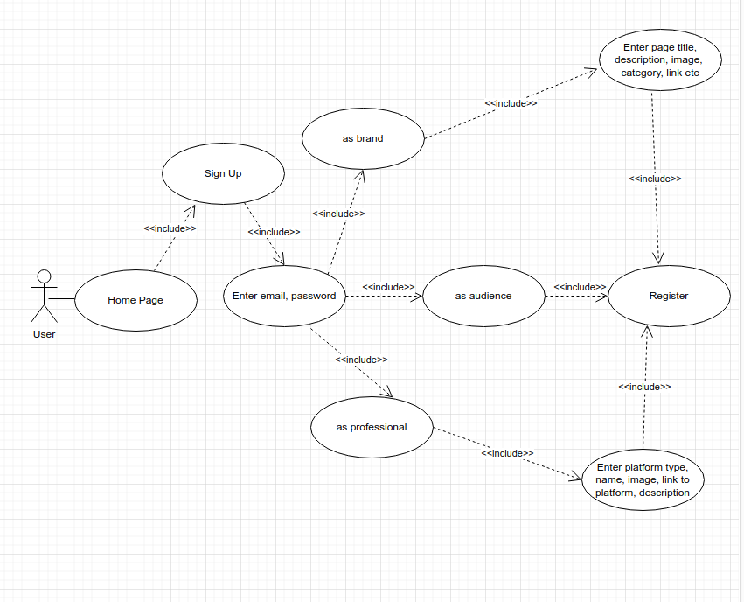
- Use-case diagram <sign up>

    - Use-case diagram 02 <Login and logout>
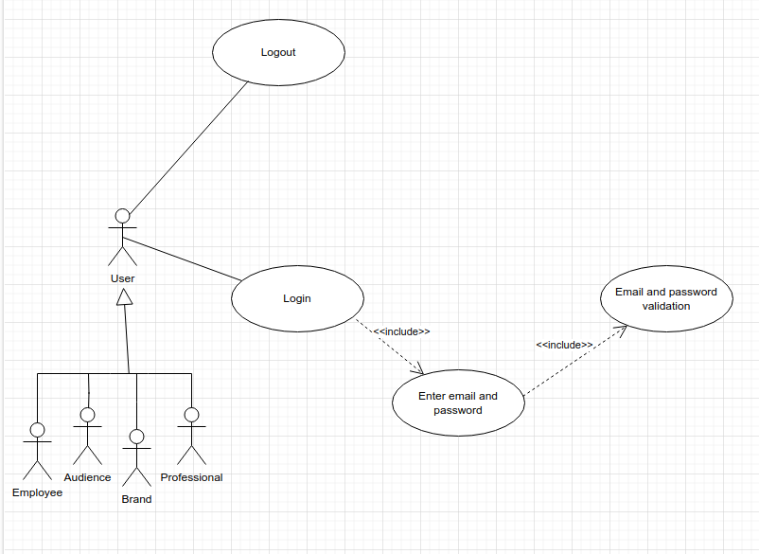
- Use-case diagram <Login and logout>

    - Use-case diagram 03 <Create group>
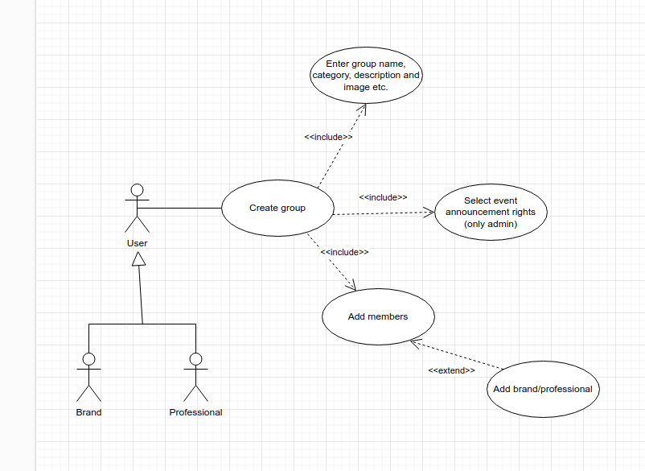
- Use-case diagram <Create group>

    - Use-case diagram 04<Add Post/Event>
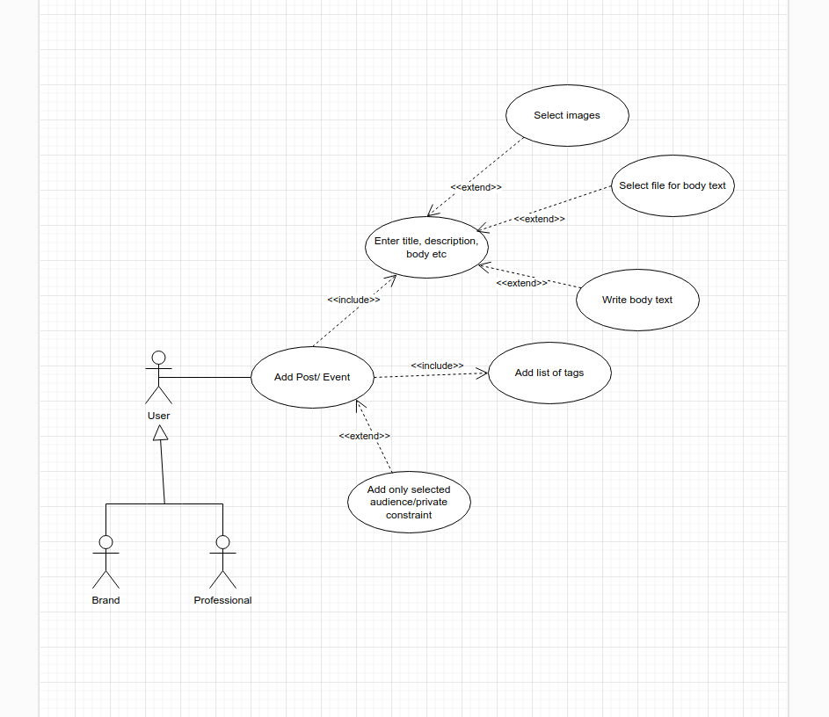
- Use-case diagram <Add Post/Event>

    - Use-case diagram 05 <Delete/ modify post/event>
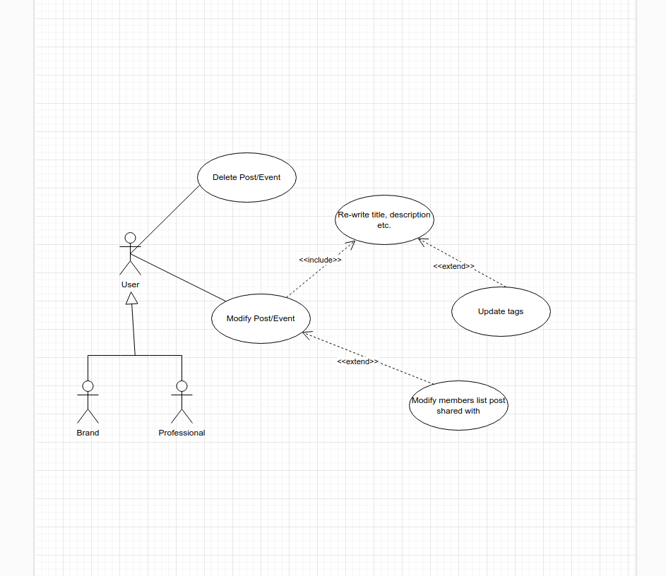
- Use-case diagram <Delete/ modify post/event>

    - Use-case diagram 06 <Hire professional>
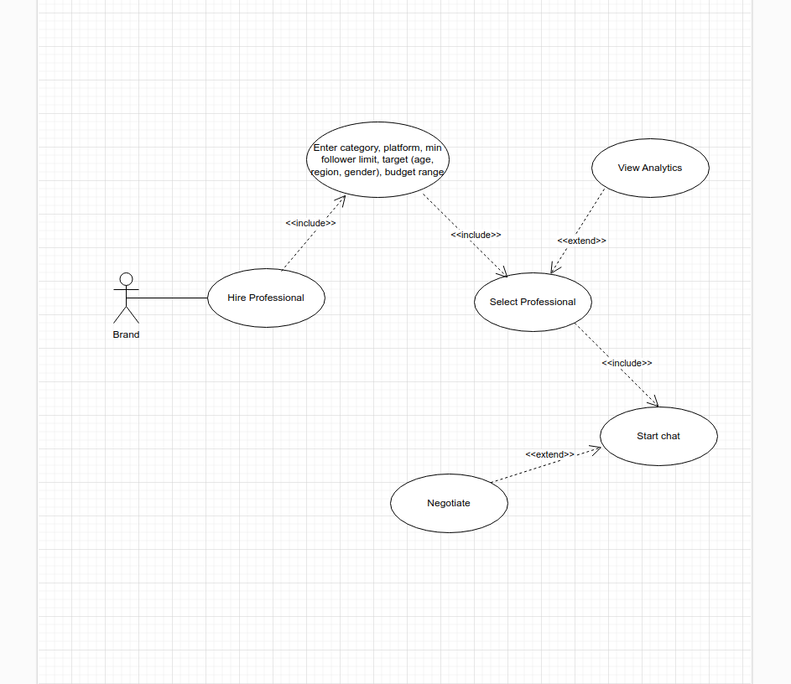
- Use-case diagram <Hire professional>

    - Use-case diagram 07 <offer contract>
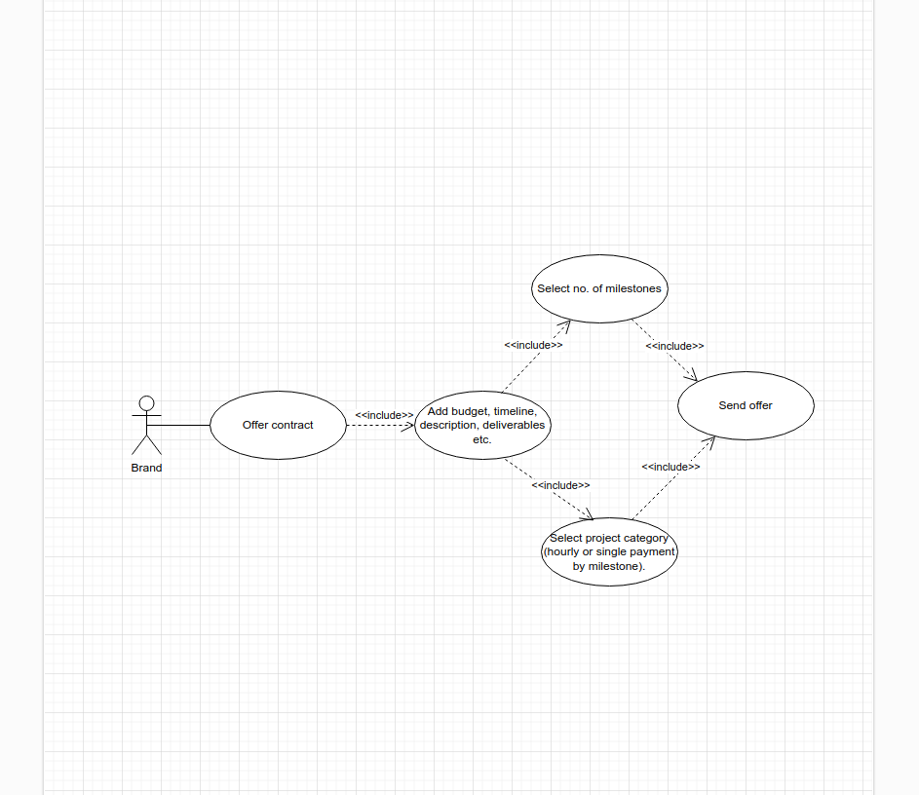
- Use-case diagram <offer contract>

    - Use-case diagram 08 <Cancel/ modify contract>
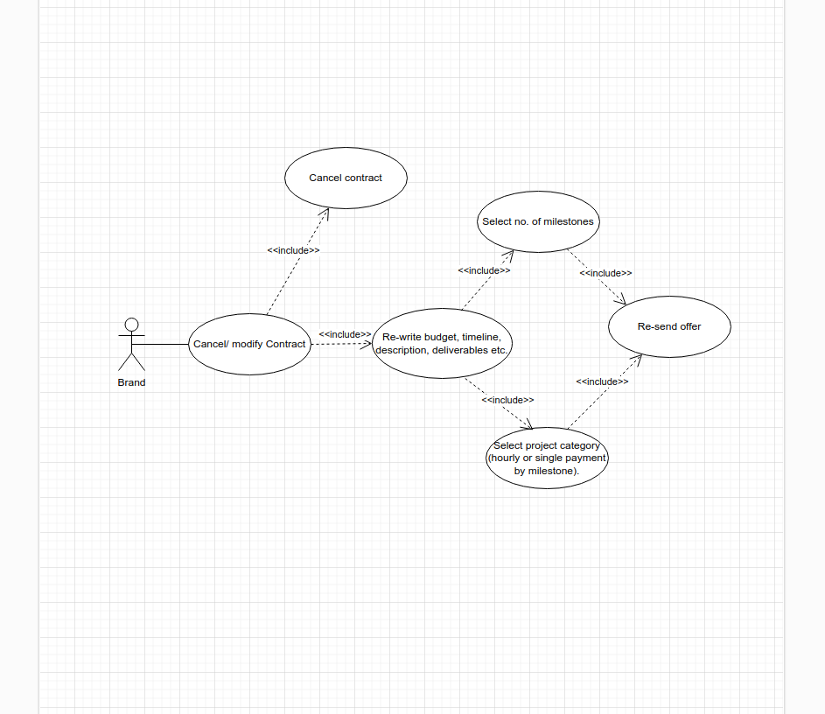
- Use-case diagram <Cancel/ modify contract>

    - Use-case diagram 09 <Approve contract>
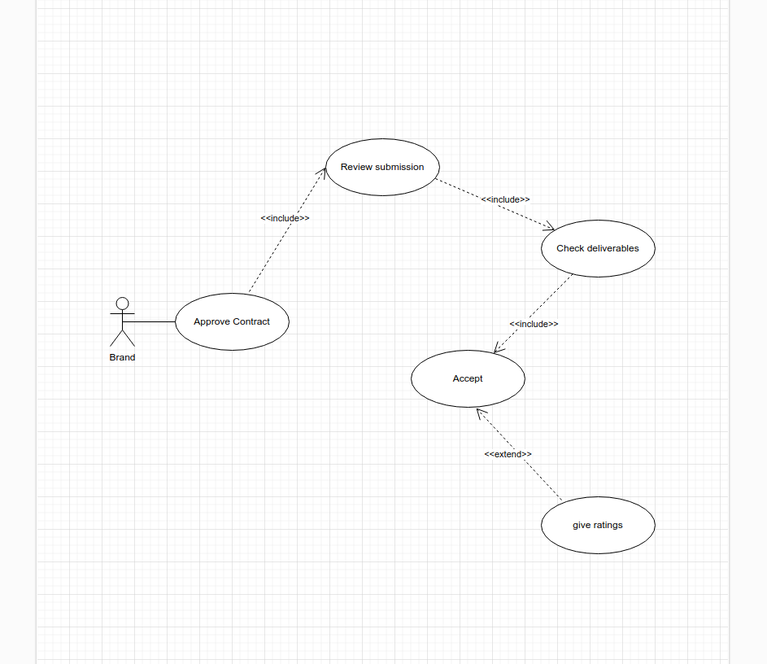
- Use-case diagram <Approve contract>

    - Use-case diagram 10 <Add payment method>
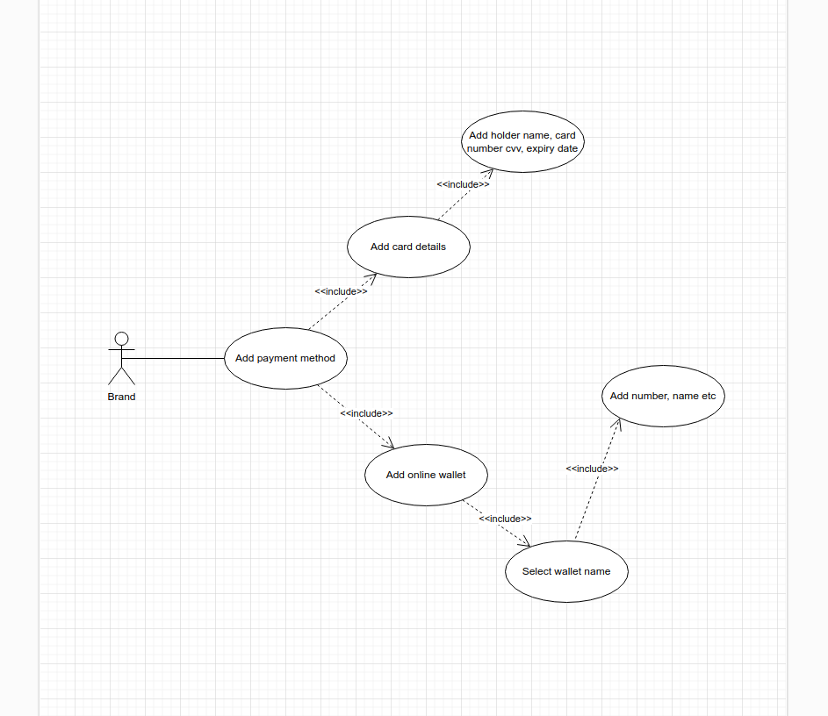
- Use-case diagram <Add payment method>

    - Use-case diagram 11 <View Analytics>
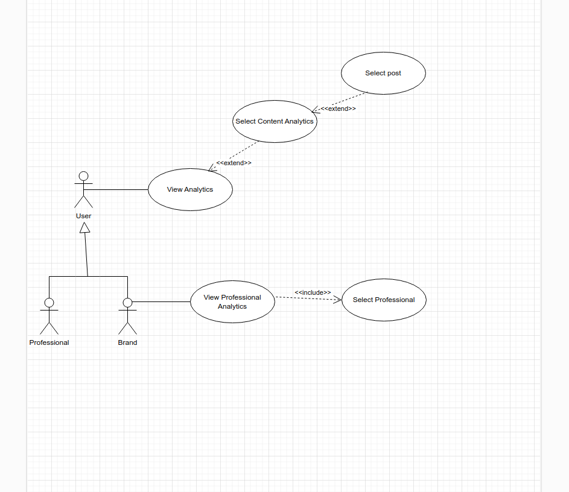

- Use-case diagram <View Analytics>

    - Use-case diagram 12 <View ongoing contracts/ submit deliverable>
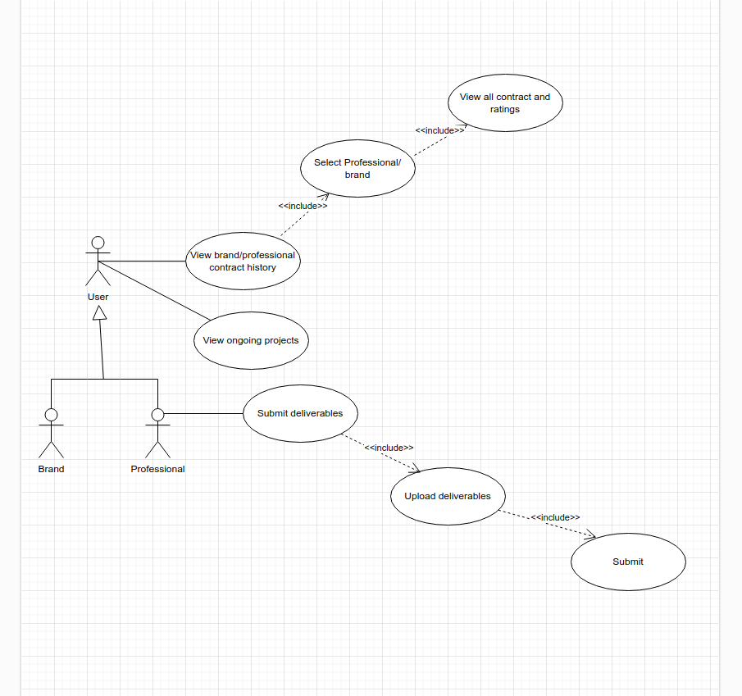
- Use-case diagram <View ongoing contracts/ submit deliverable>

    - Use-case diagram 13 <delete/modify profile>
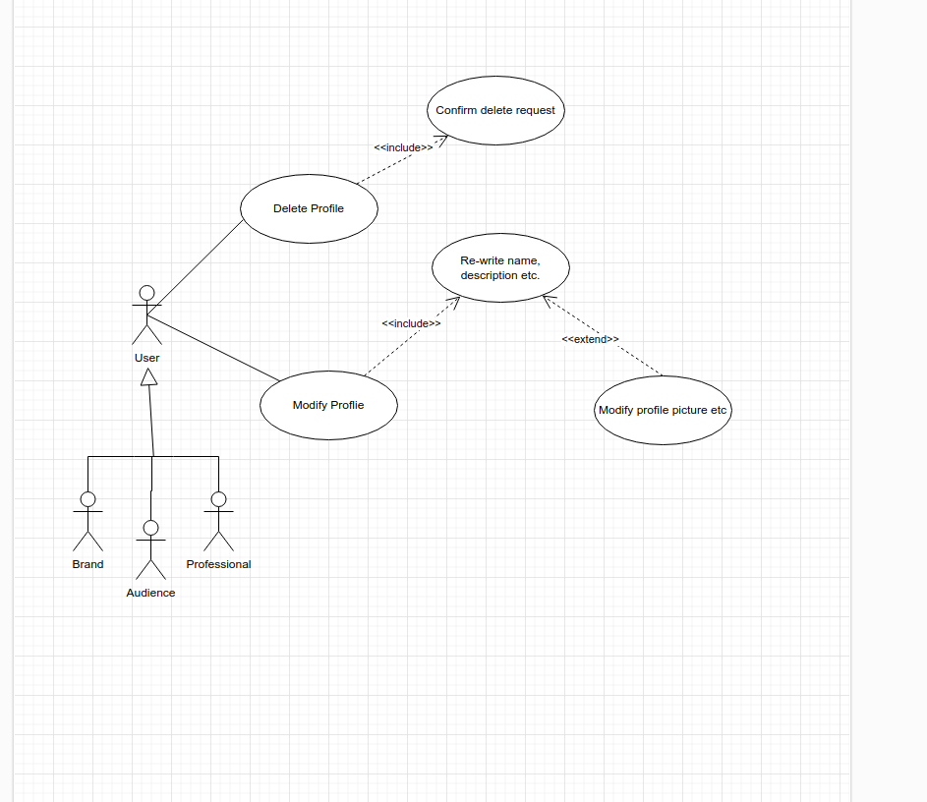
- Use-case diagram<delete/modify profile>

    - Use-case diagram 14 <view/rate contract>
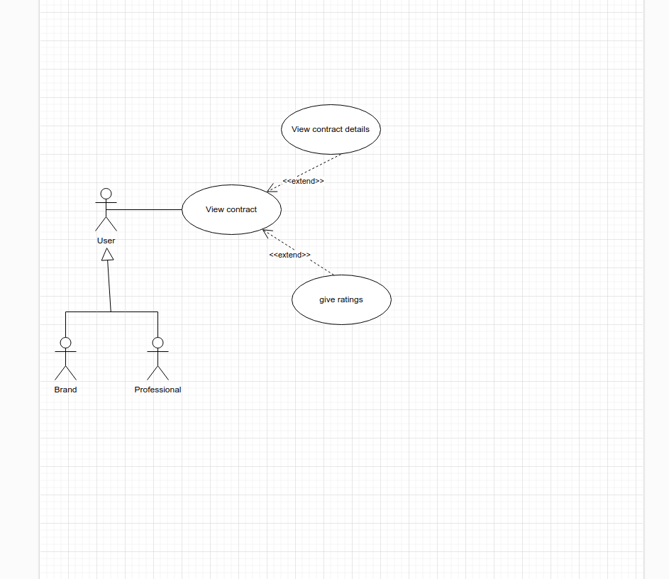
- Use-case diagram <view/rate contract>

    - Use-case diagram 15 <Add withdrawal method>
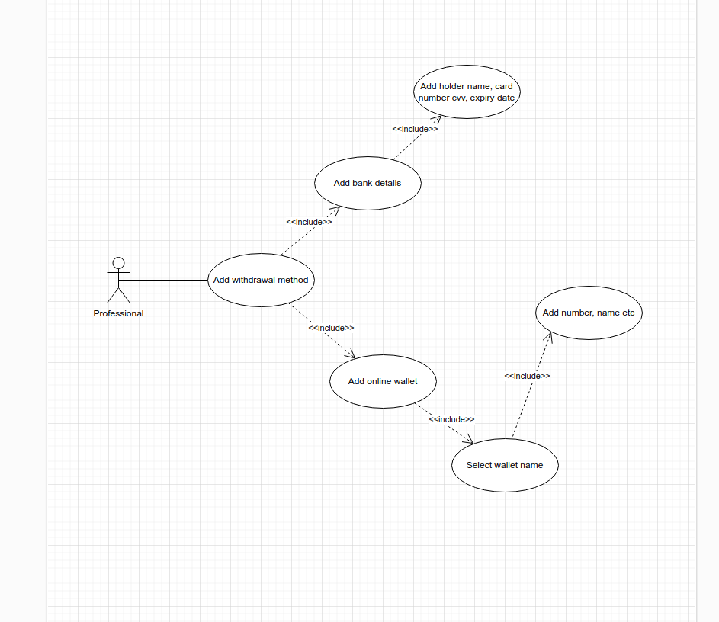
- Use-case diagram<Add withdrawal method>

    - Use-case diagram 16 <Withdraw amount>
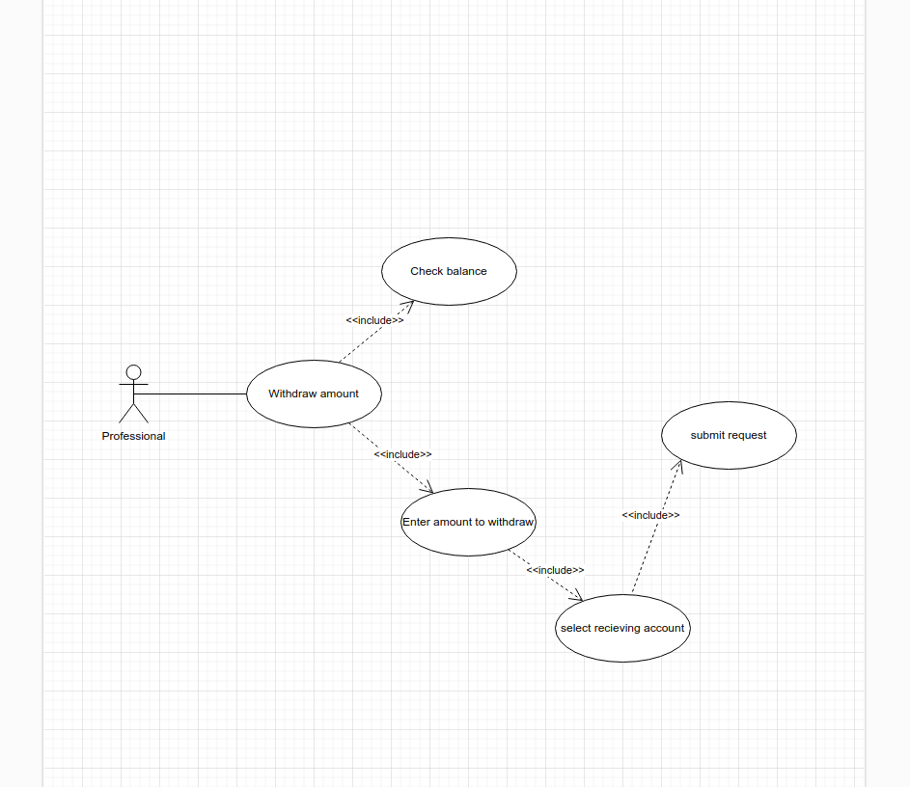
- Use-case diagram <Withdraw amount>

    - Use-case diagram 17<Contact Help Desk>
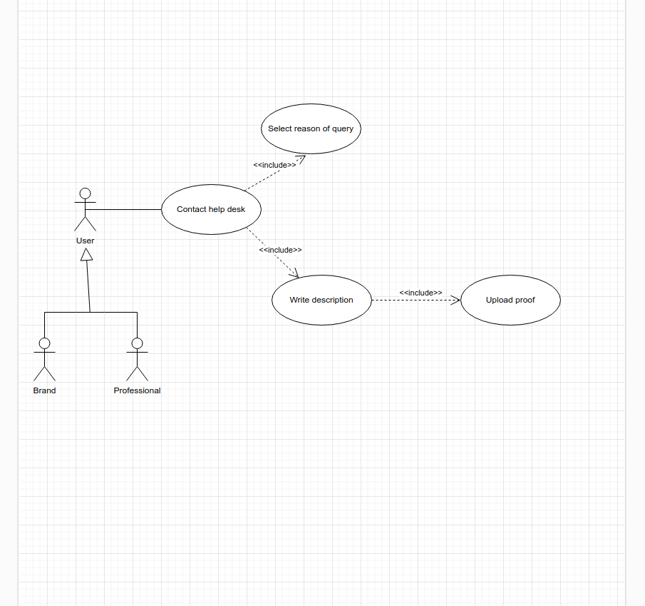
- Use-case diagram<Contact Help Desk>

    - Use-case diagram 18<View Queries>
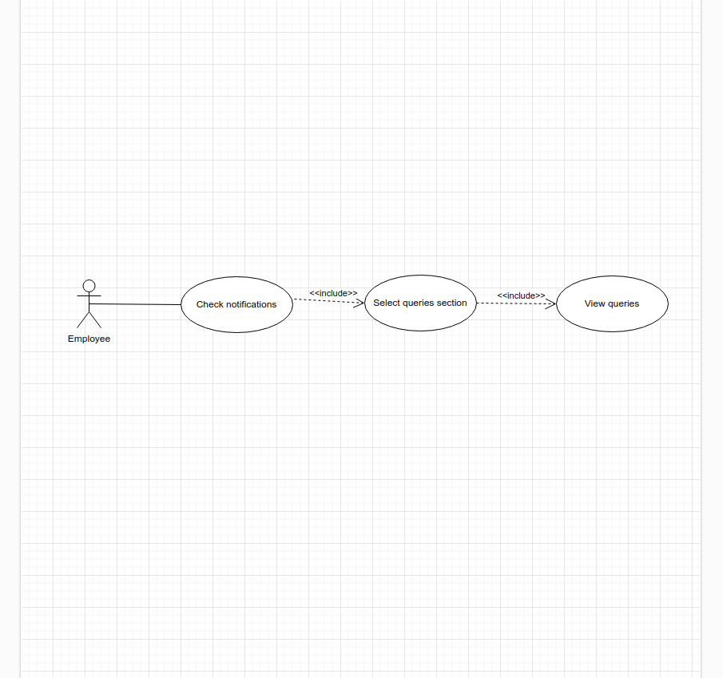
- Use-case diagram <View Queries>

    - Use-case diagram 19<Contact query parties>
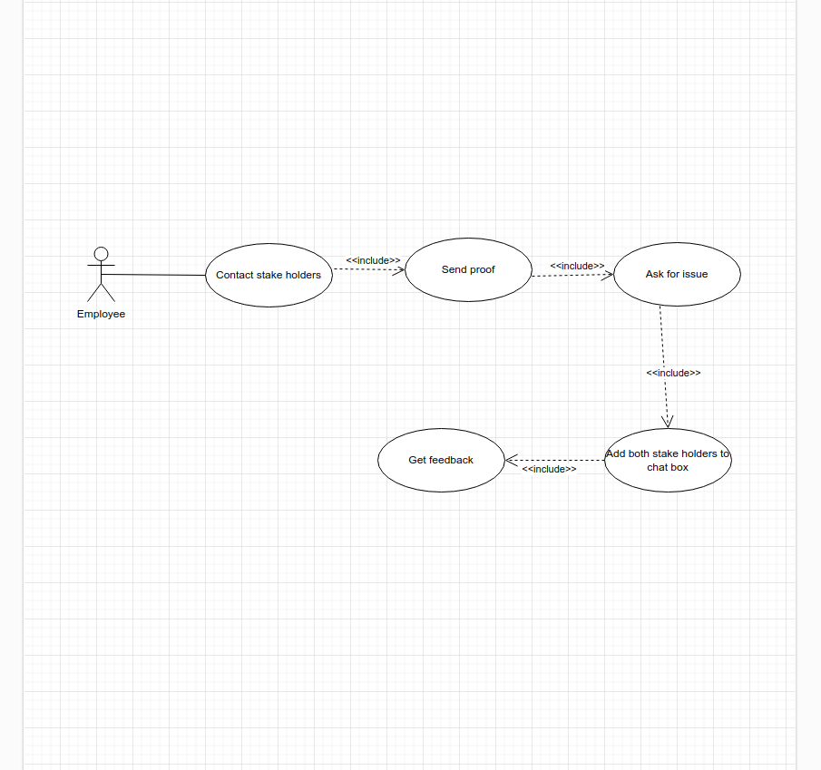
- Use-case diagram <Contact query parties>

    - Use-case diagram 20<Modify query status>
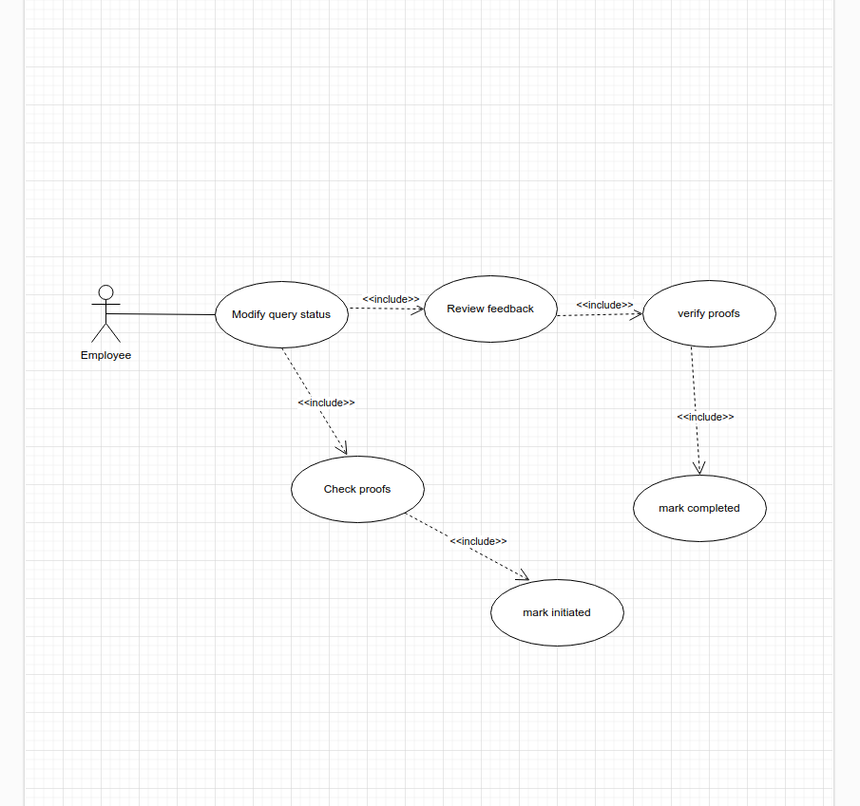
- Use-case diagram<Modify query status>

    - Use-case diagram 21<Respond to query>
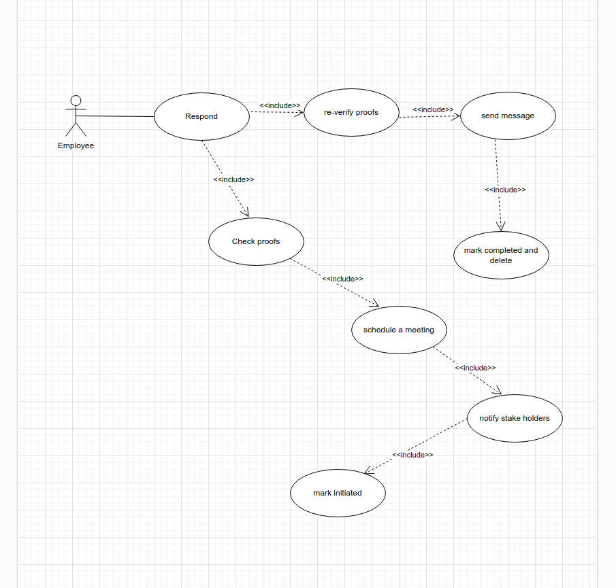
- Use-case diagram<Respond to query>

    - Use-case diagram 22<Follow business page>
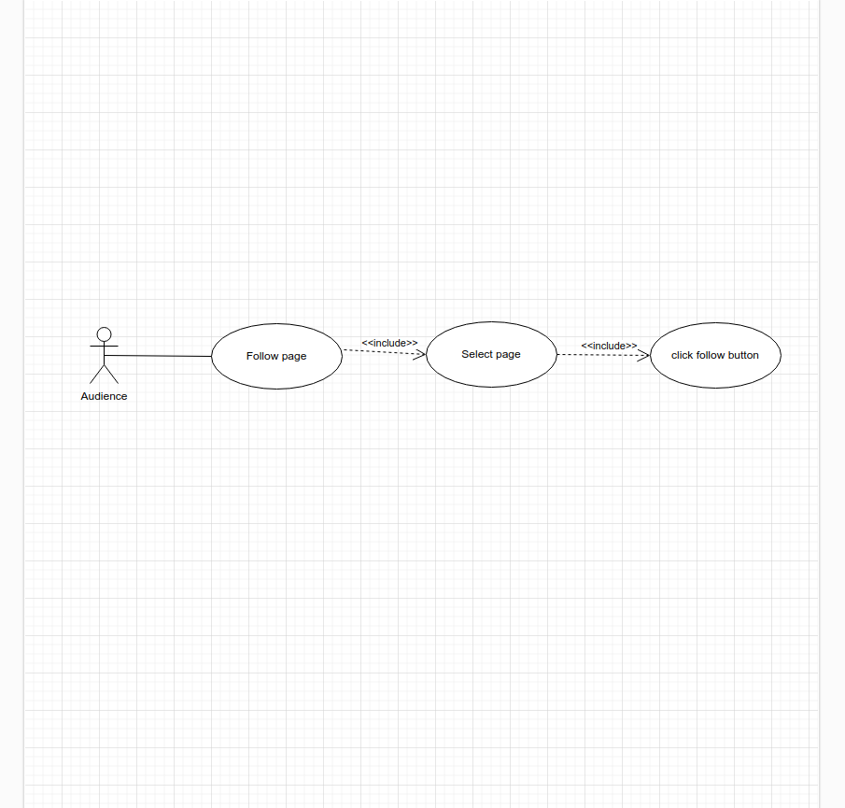
- Use-case diagram <Follow business page>

    - Use-case diagram 23<Join group>
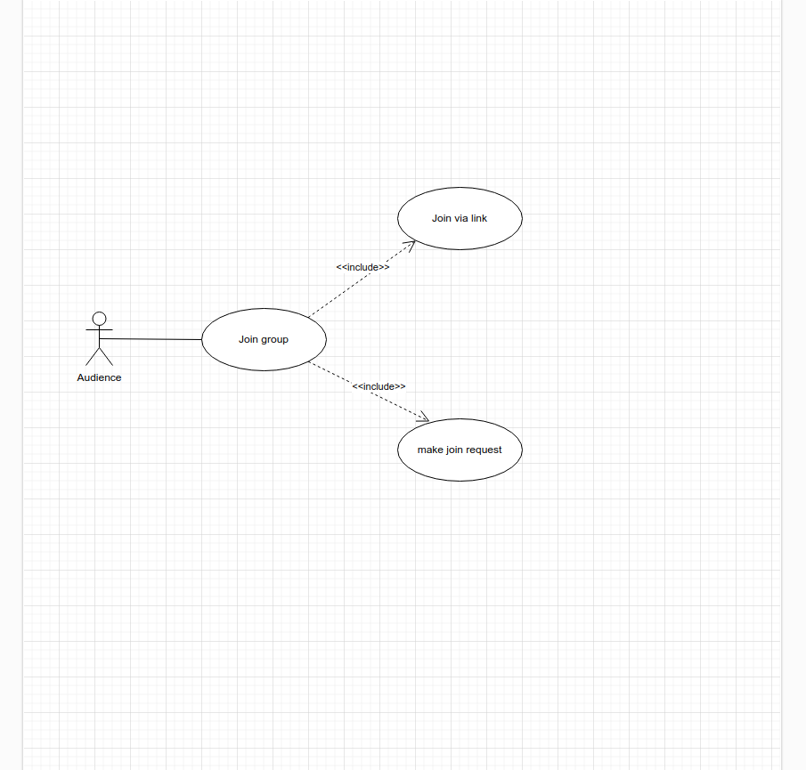
- Use-case diagram<Join group>

    - Use-case diagram 24<Interact with post>
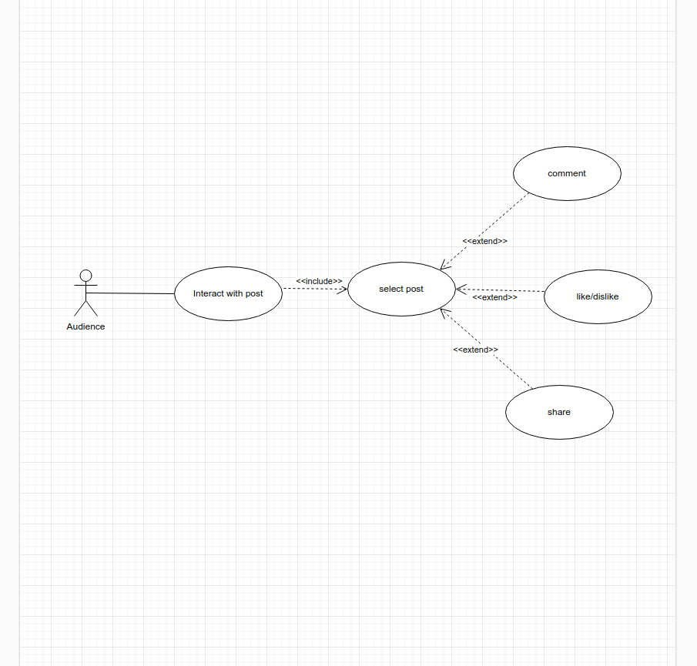
- Use-case diagram <Interact with post>

    - Use-case diagram 25<Modify/delete interaction>
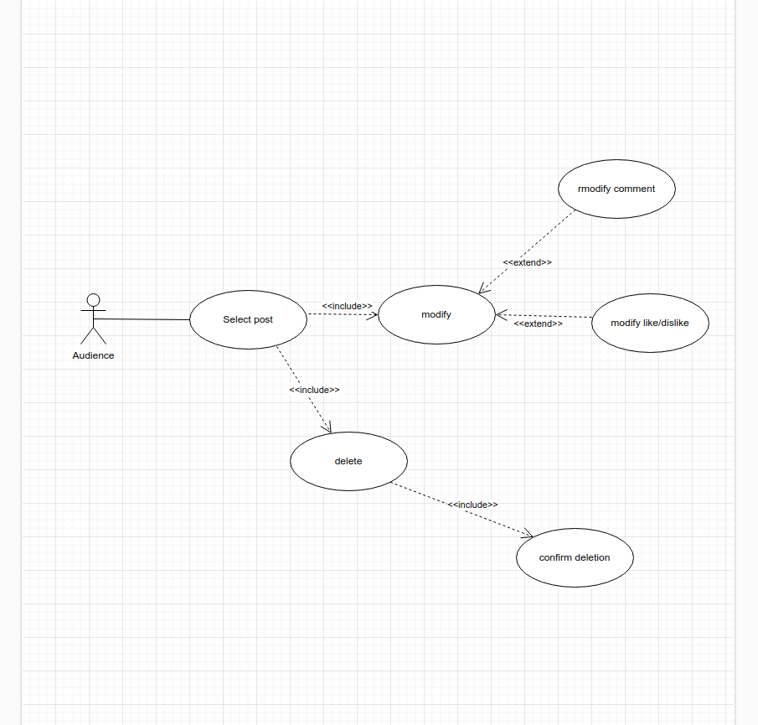
- Use-case diagram <Modify/delete interaction>

    - Use-case diagram 26<Request delete account>
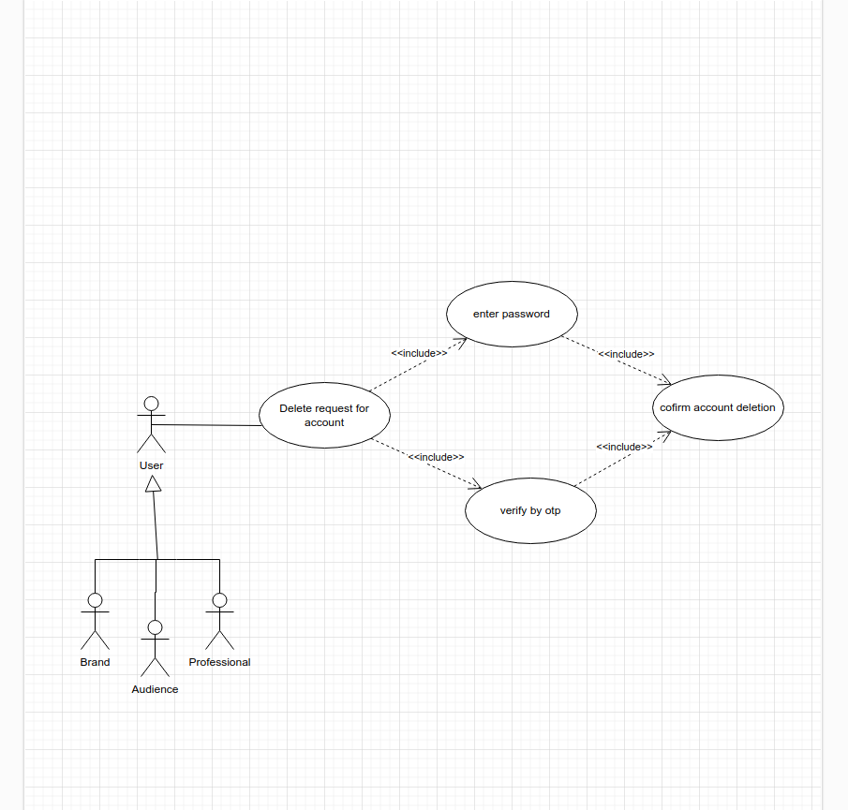
- Use-case diagram<Request delete account>

    - Use-case diagram 27<Search>
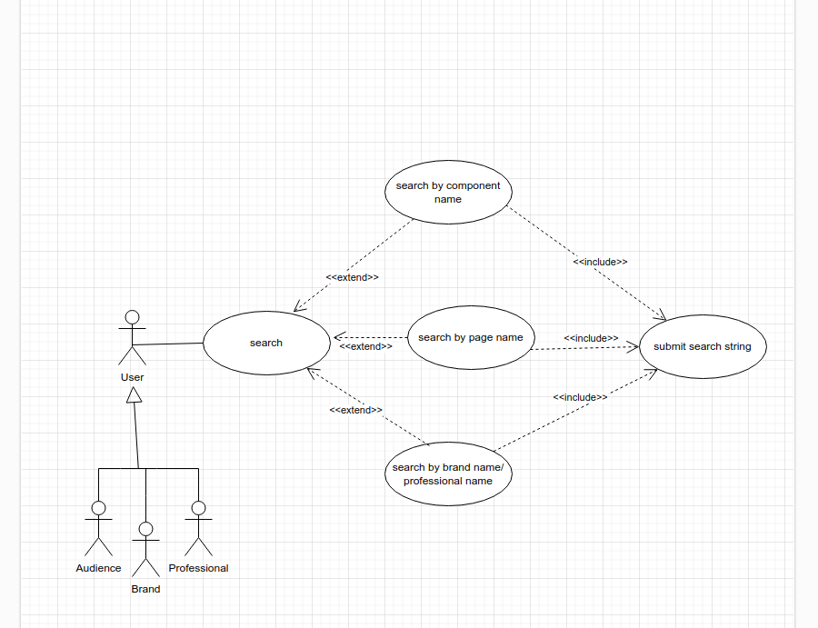
- Use-case diagram<Search>

Use case design Software development life cycle model (justification on why this particular model is considered)

Agile Development Model
The Agile development model is recommended for this project due to its flexibility, adaptability, and emphasis on iterative progress. Here's the justification for selecting Agile:
      - Flexibility and Adaptability:
Agile allows for changes and adjustments throughout the project life-cycle. Given the diverse features in use cases, like creating groups, handling payments, and interacting with users, Agile's iterative approach enables us to adapt to new requirements or changes in project scope without significant disruption.
      - Continuous Feedback and Collaboration:
Agile encourages collaboration among stakeholders, including developers, testers, and end-users. This approach ensures that feedback is continuously integrated into the development process, leading to better alignment with user expectations. This is particularly valuable in projects that require ongoing interaction with customers, as is the case with our project's focus on brands, professionals, and general users.
      - Early Delivery and Incremental Progress:
Agile promotes delivering working software in short iterations or sprints, typically two to four weeks long. This allows for early delivery of key features, enabling stakeholders to test, validate, and provide feedback. For our project, this incremental progress ensures that critical functionalities, such as sign-up, login, and payment methods, are developed and tested early, reducing the risk of major issues at the end of the project.
      - Focus on User Stories and Customer Value:
Agile development uses user stories to prioritize tasks based on customer(industry stake holder) value. Given the variety of actors and interactions in our project, this approach helps ensure that the most valuable features are developed first, aligning with business objectives and user needs.
      - Reduced Risk and Improved Quality:
Agile's iterative approach reduces the risk of significant issues emerging late in the development process. Continuous testing and feedback contribute to higher quality, as issues are addressed as they arise rather than accumulating until the end.

Chapter 3: System Design

Work breakdown structure (WBS)
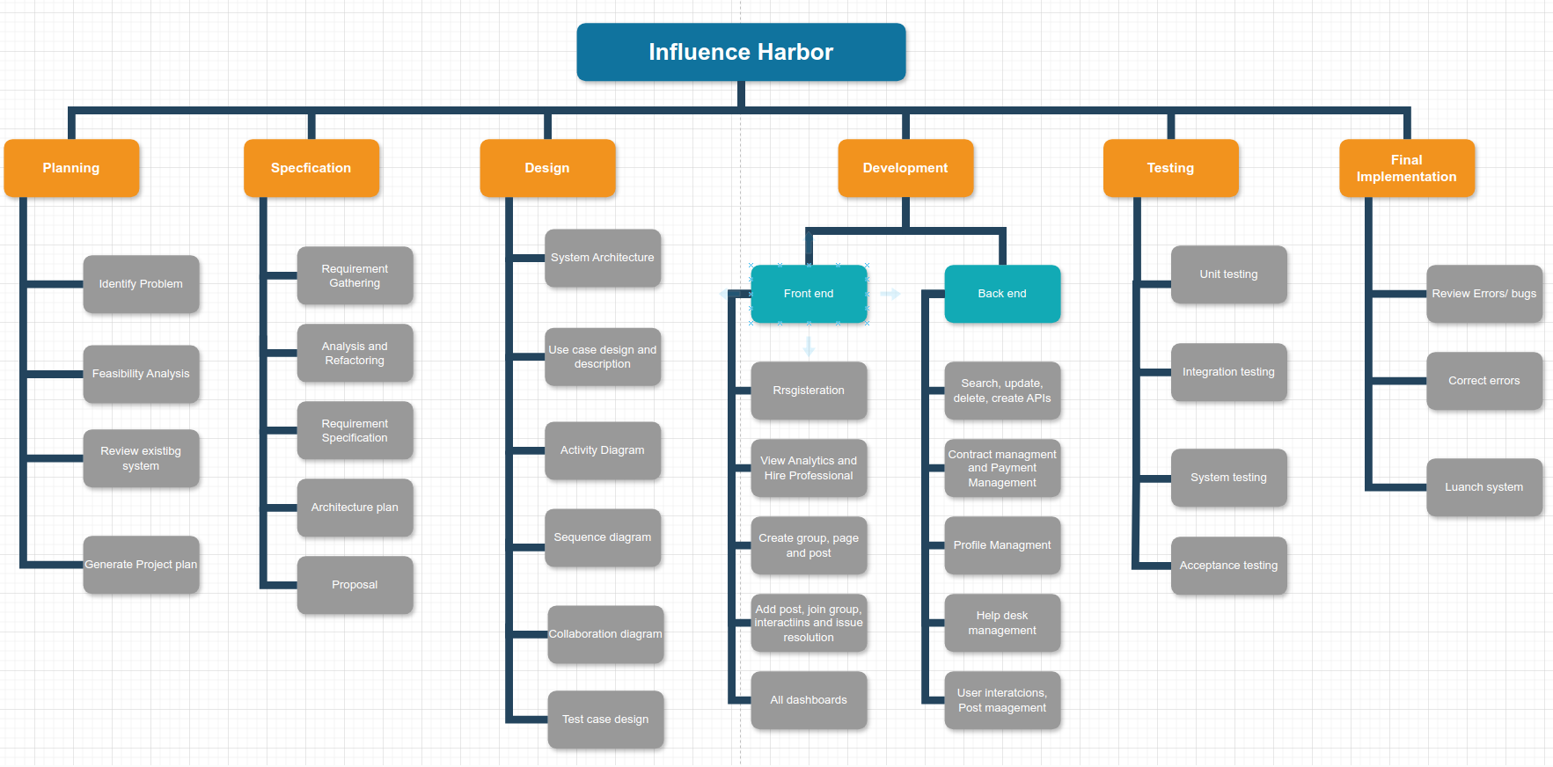

- Work breakdown structure (WBS)

Activity diagram
    - Activity diagram 01<Sign up>
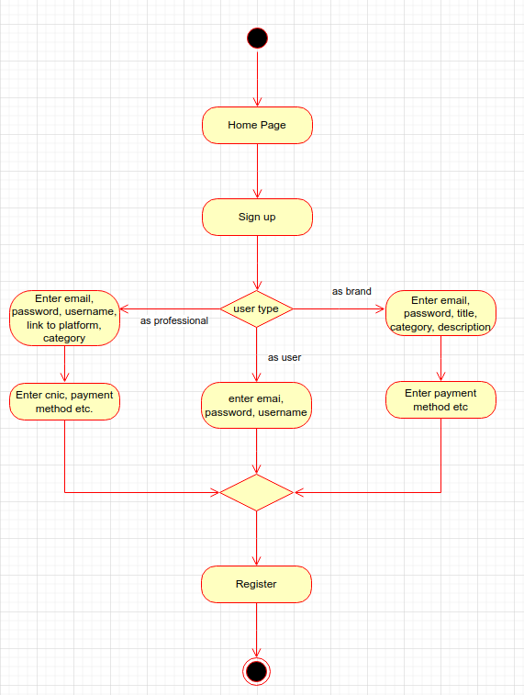

- Activity diagram<Sign up>

    - Activity diagram 02<Login and logout>
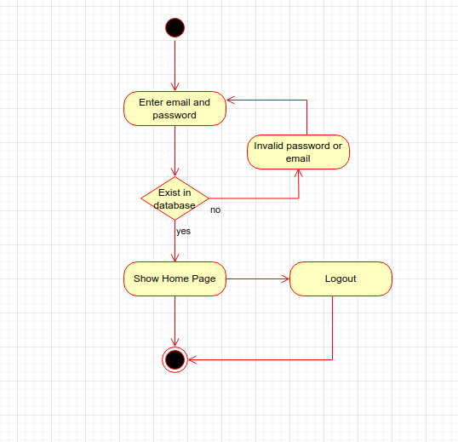
- Activity diagram<Login and logout>

    - Activity diagram 03<Create group>
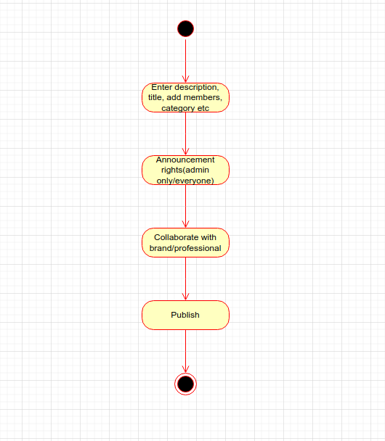

- Activity diagram <Create group>

    - Activity diagram 04<Add Post/Announcement>
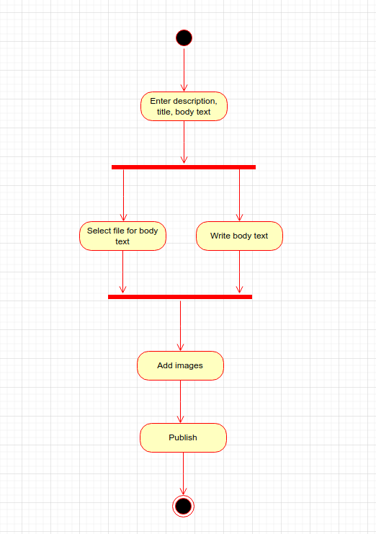

- Activity diagram<Add Post/Announcement>

    - Activity diagram 05<Delete/modify post>
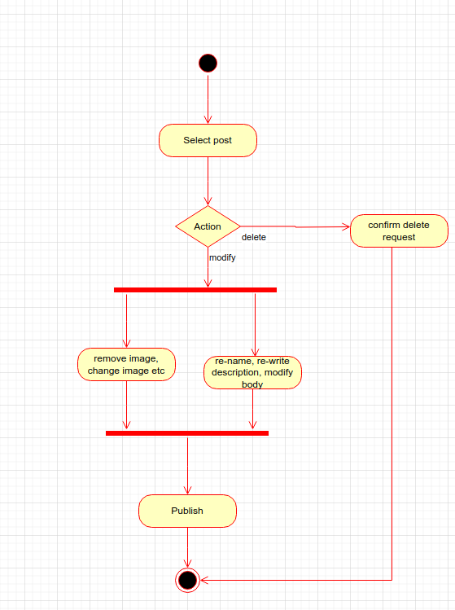
- Activity diagram <Delete/modify post>

    - Activity diagram 06<Hire Professional>
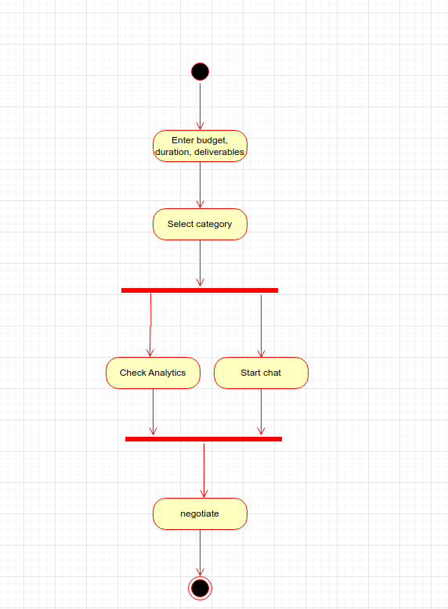
- Activity diagram <Hire Professional>

    - Activity diagram 07<Offer contract>
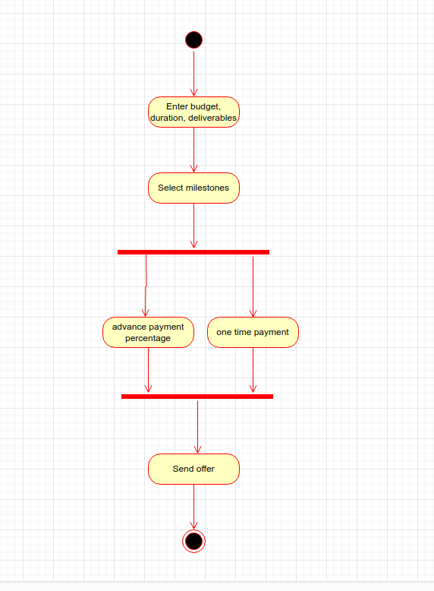

- Activity diagram <Offer contract>

    - Activity diagram 08<cancel/modify contract>
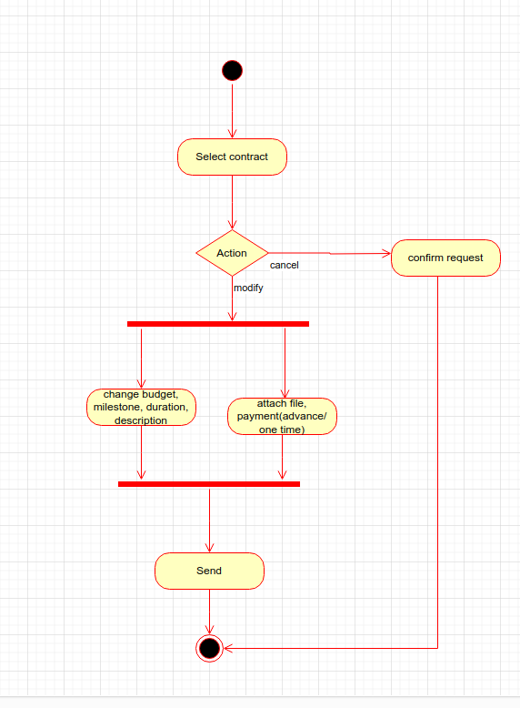
- Activity diagram<cancel/modify contract>

    - Activity diagram 09<Approve contract>
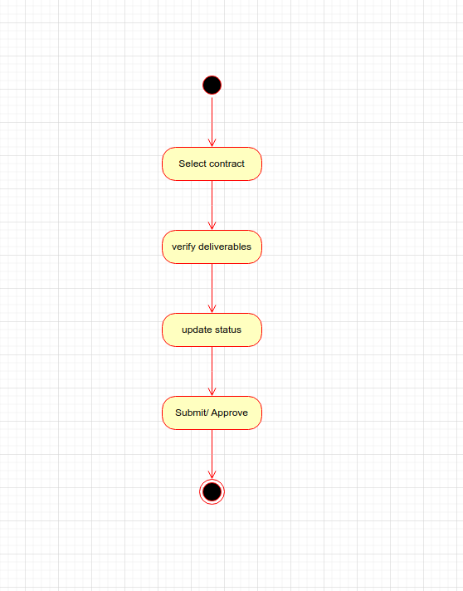

- Activity diagram <Approve contract>

    - Activity diagram 10<Add payment method>
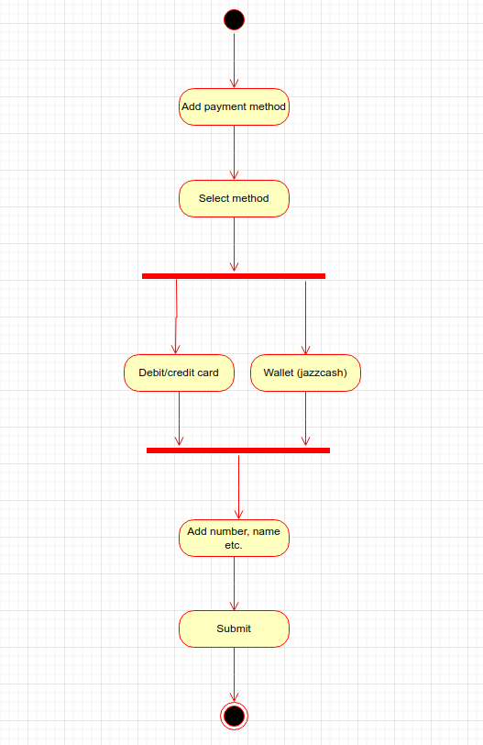
- Activity diagram<Add payment method>

    - Activity diagram 11<View Analytics>
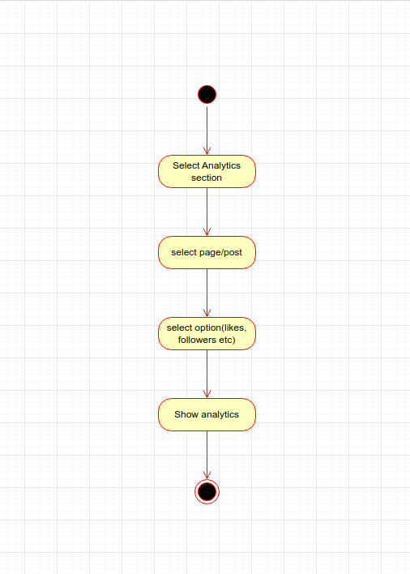
- Activity diagram<View Analytics>

    - Activity diagram 12<Submit deliverables>
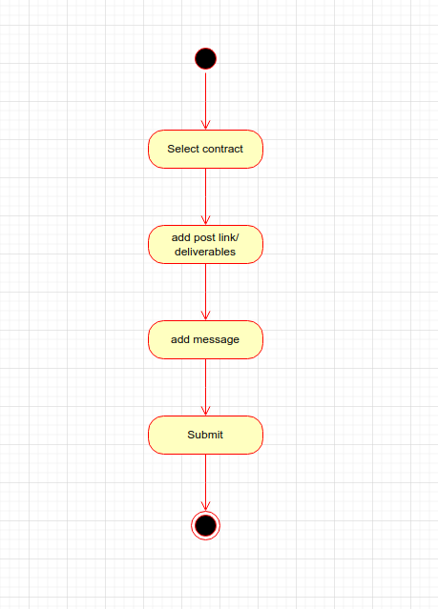
- Activity diagram<Submit deliverables>

    - Activity diagram 13<delete/ modify profile>
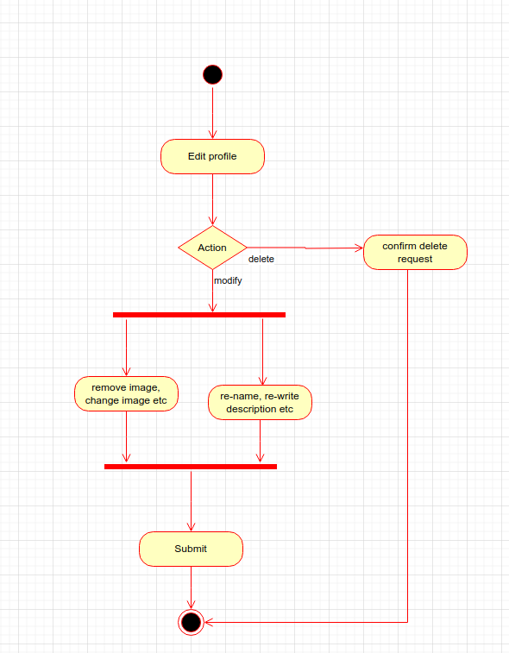

- Activity diagram <delete/ modify profile>

    - Activity diagram 14<rate contract>
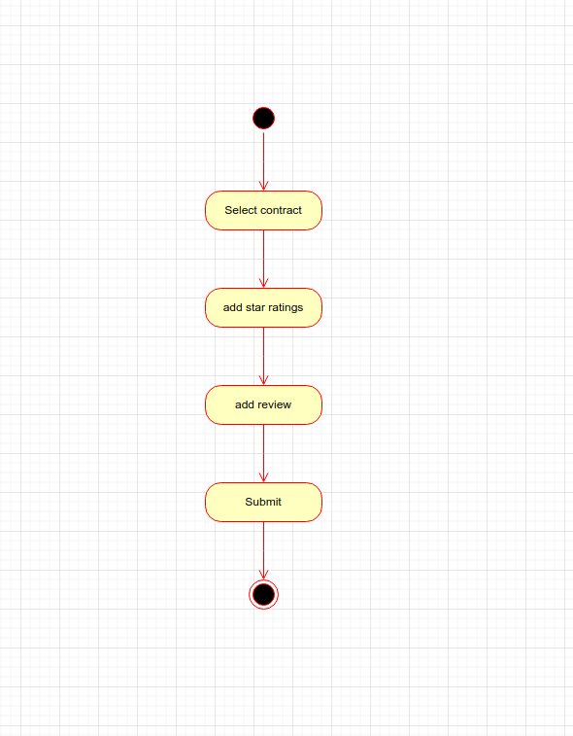

- Activity diagram<rate contract>

    - Activity diagram 15<Add withdrawal method>
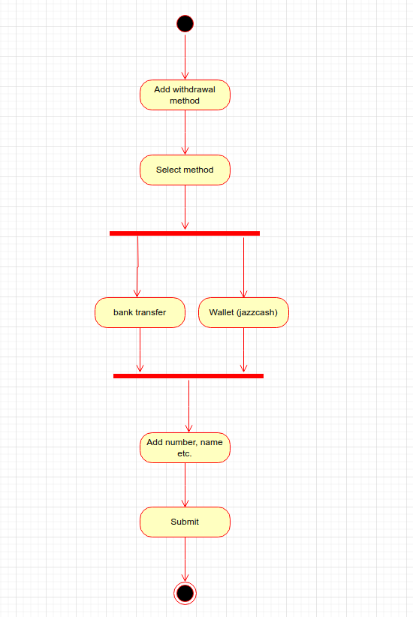

- Activity diagram<Add withdrawal method>

    - Activity diagram 16<Withdraw amount>
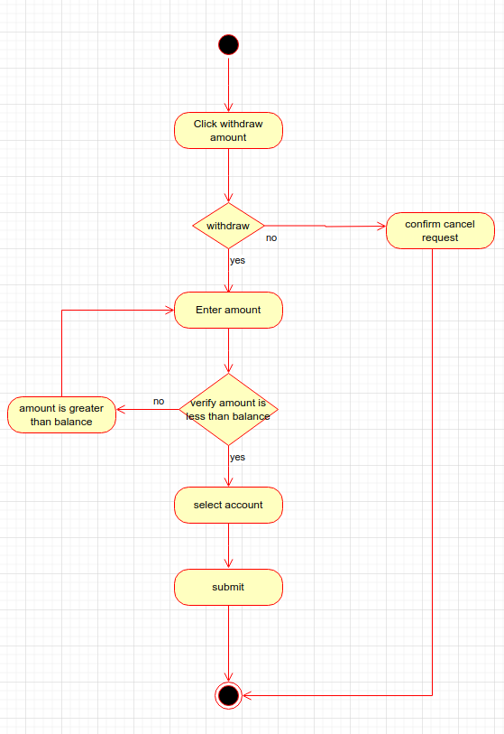
- Activity diagram<Withdraw amount>

    - Activity diagram 17<Contact Help desk>
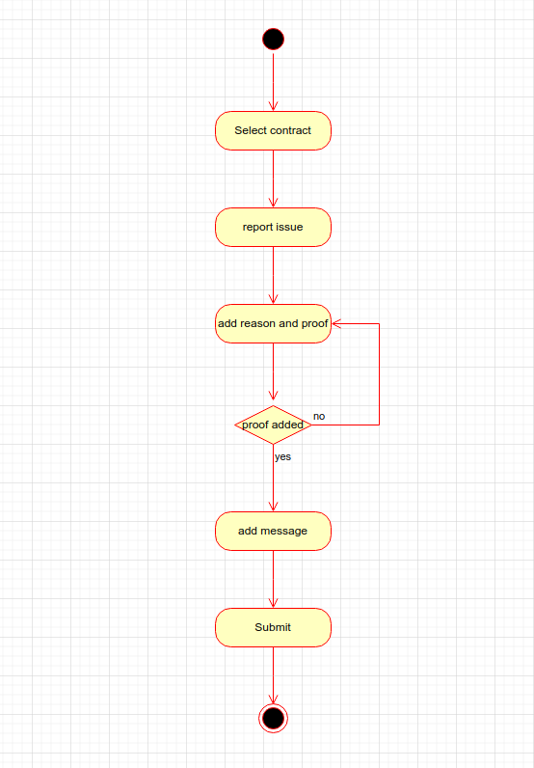
- Activity diagram <Contact Help desk>

    - Activity diagram 18<View Queries>
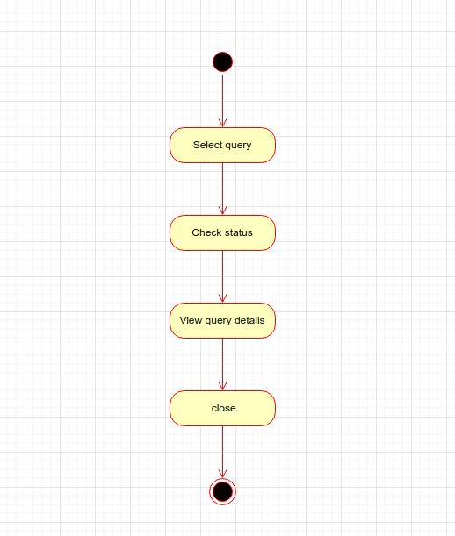
- Activity diagram<View Queries>

    - Activity diagram 19<Contact query parties>
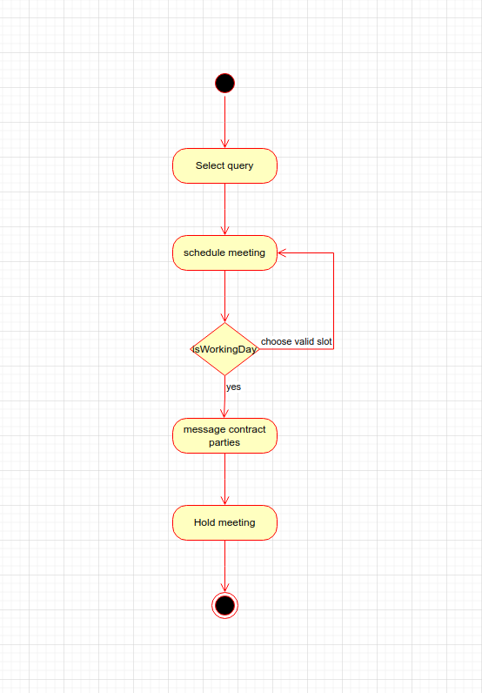
- Activity diagram <Contact query parties>

    - Activity diagram 20<Modify query status>
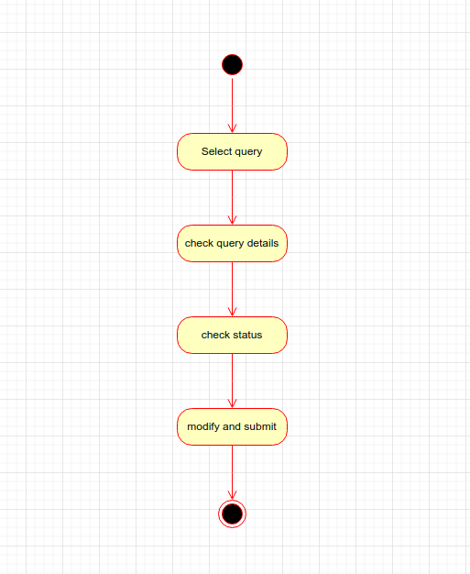
- Activity diagram <Modify query status>

    - Activity diagram 21<Respond to query>
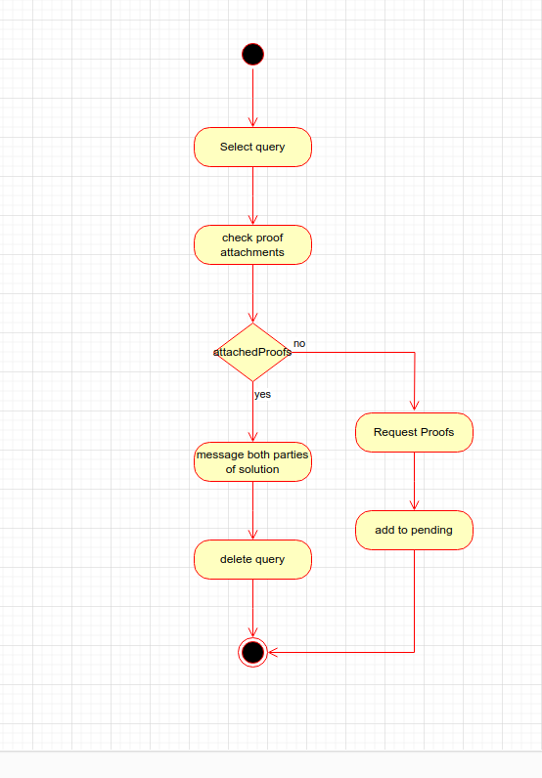
- Activity diagram <Respond to query>

    - Activity diagram 22<Follow page>
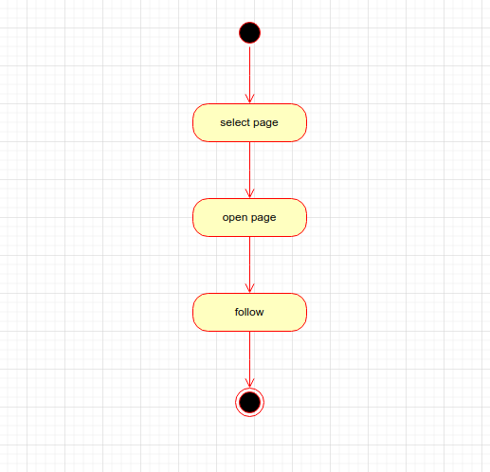
- Activity diagram <Follow page>

    - Activity diagram 23<Join group>
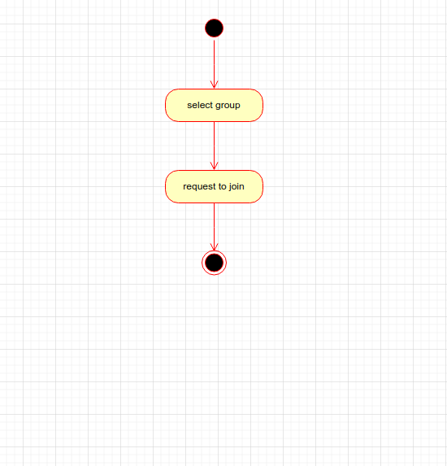
- Activity diagram<Join group>

    - Activity diagram 24<Interact with post>
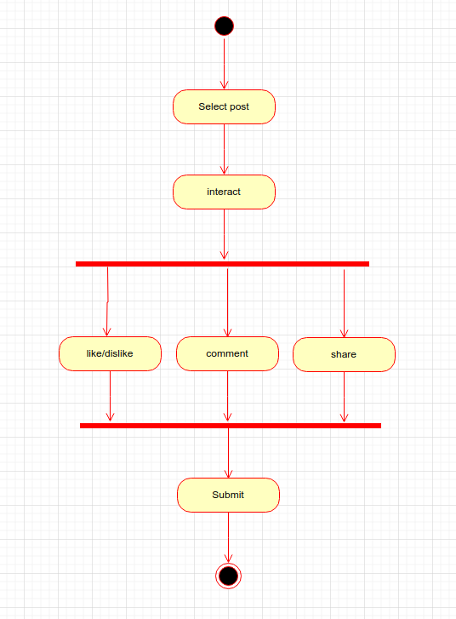
- Activity diagram <Interact with post>

    - Activity diagram 25<modify/ delete interaction>
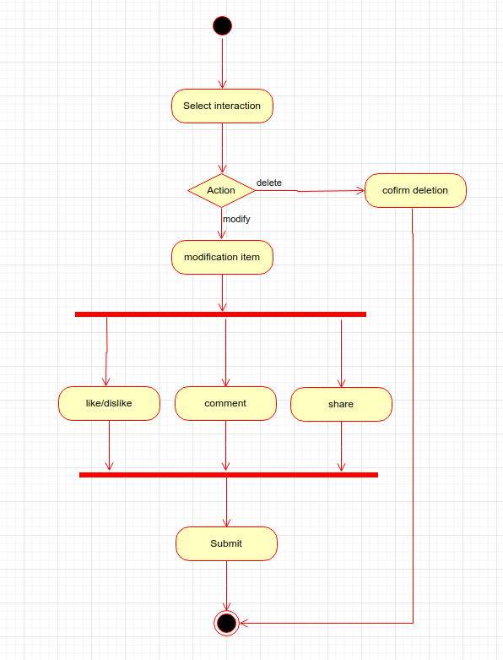
- Activity diagram<modify/ delete interaction>

    - Activity diagram 26<Account deletion request>
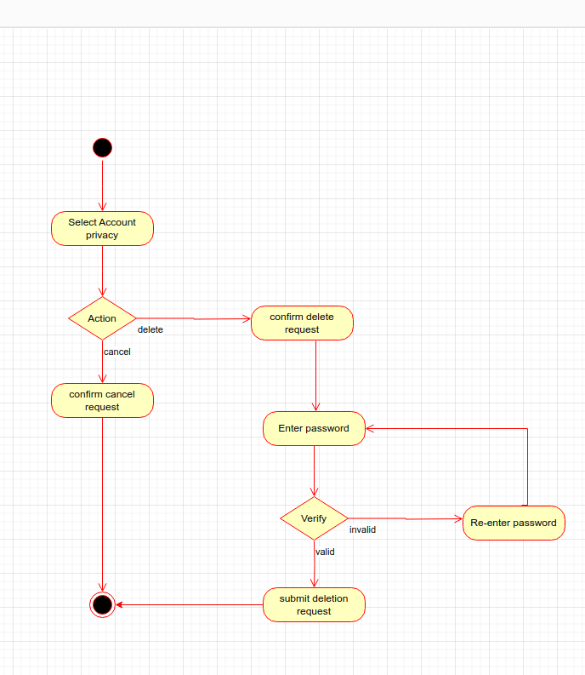
- Activity diagram <Account deletion request>

    - Activity diagram 27<Search>
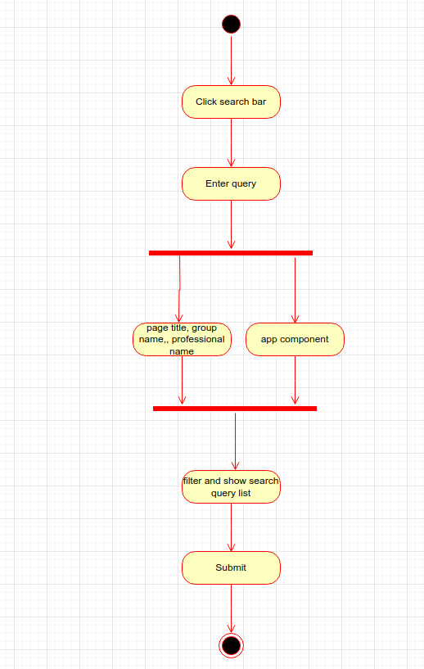
- Activity diagram <Search>

Sequence diagram
    - Sequence diagram 01<Sign Up>
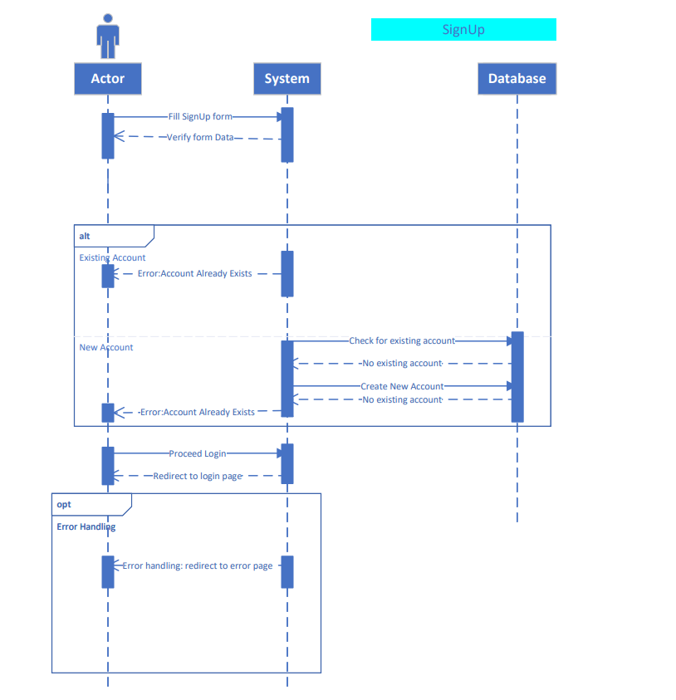
- Sequence diagram <Sign Up>

    - Sequence diagram 02<Login and Logout>
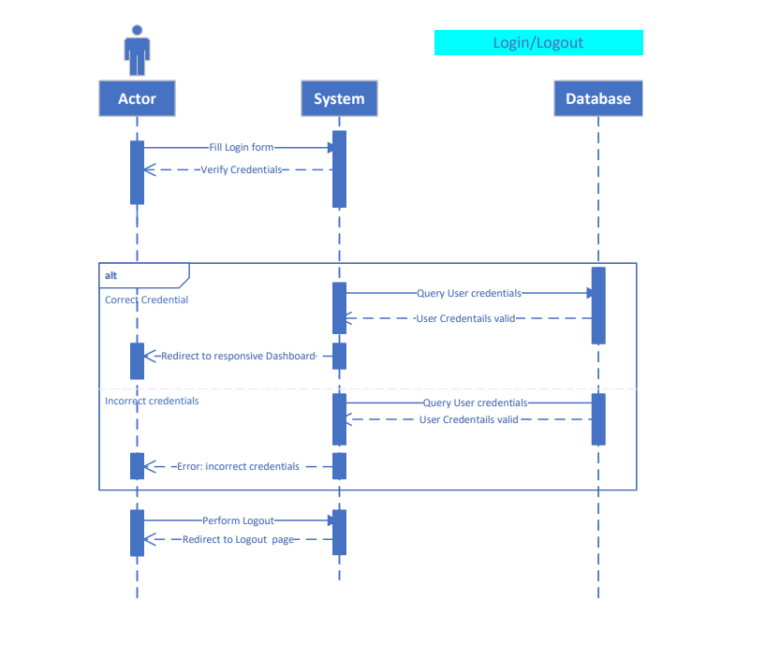
- Sequence diagram <Login and Logout>

    - Sequence diagram 03<Add Post/Event>
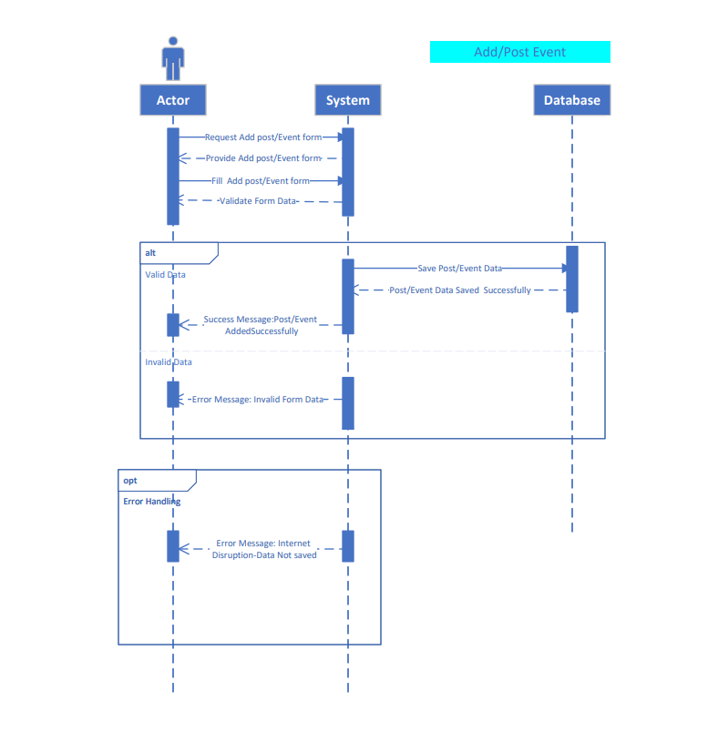
- Sequence diagram<Add Post/Event>

    - Sequence diagram 04<Add Payment method>
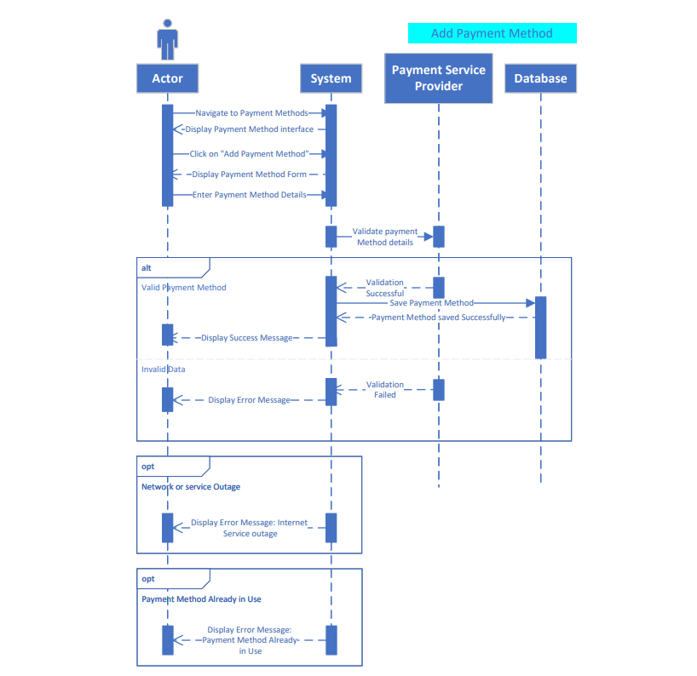
- Sequence diagram <Add Payment method>

    - Sequence diagram 05<View Analytics>
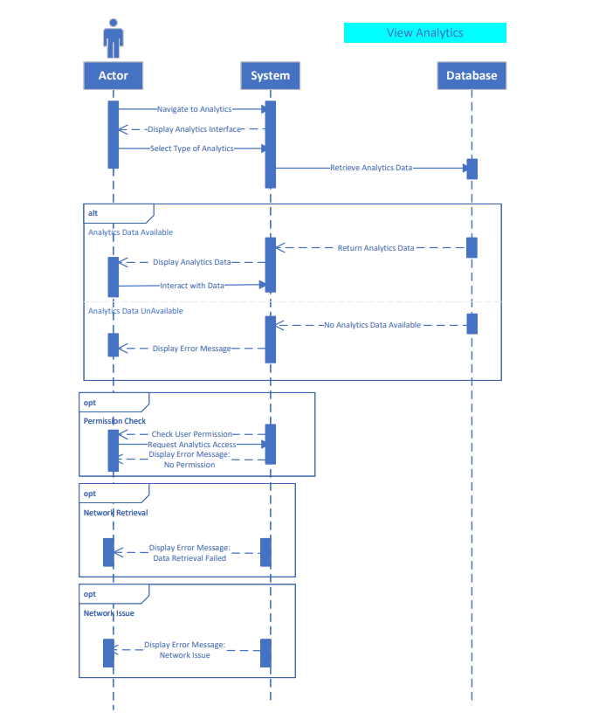
- Sequence diagram <View Analytics>

    - Sequence diagram 06<Add withdrawal method>
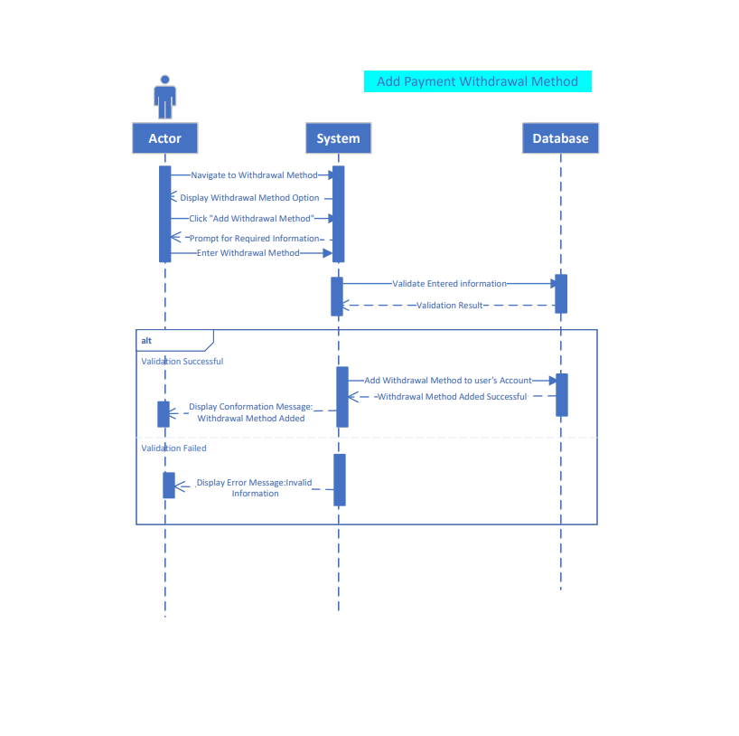
- Sequence diagram <Add withdrawal method>

    - Sequence diagram 07<Approve Contract>
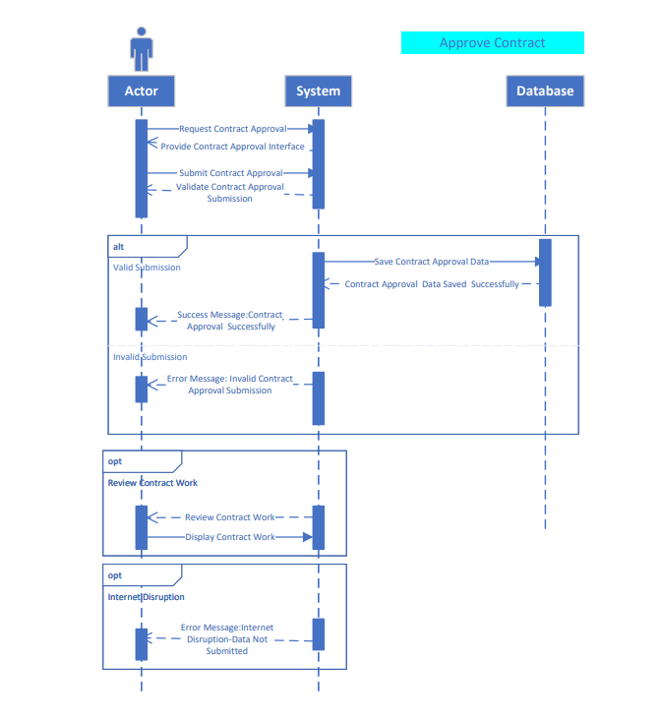
- Sequence diagram <Approve Contract>

    - Sequence diagram 08<Approve account deletion request>
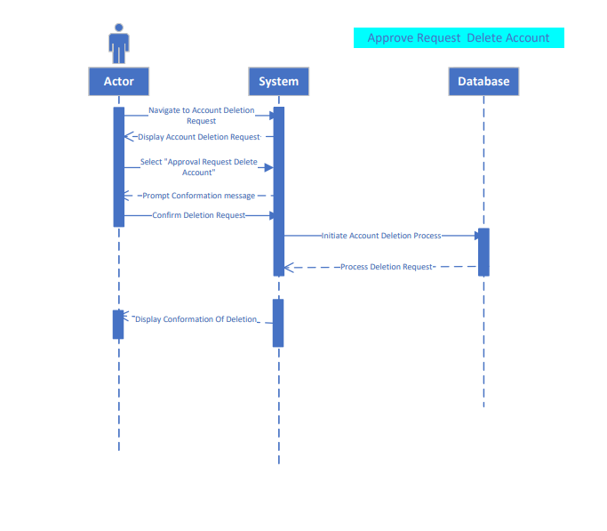

- Sequence diagram <Approve account deletion request>

    - Sequence diagram 09<Follow page>
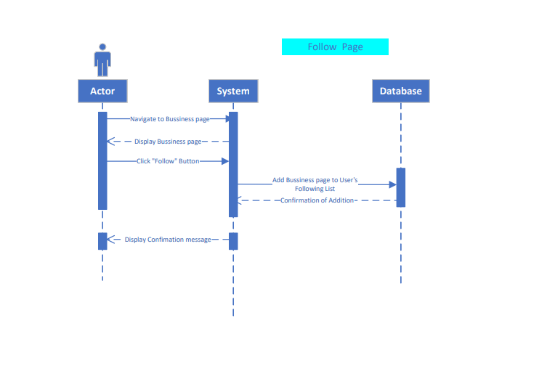
- Sequence diagram<Follow page>

    - Sequence diagram 10<Search>
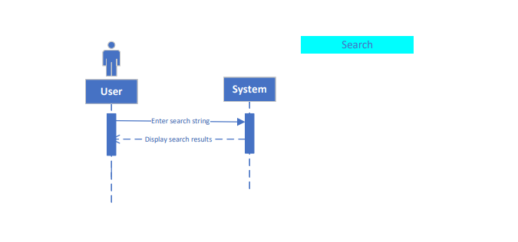
- Sequence diagram <Search>

    - Sequence diagram 11<Cancel/modify contract>

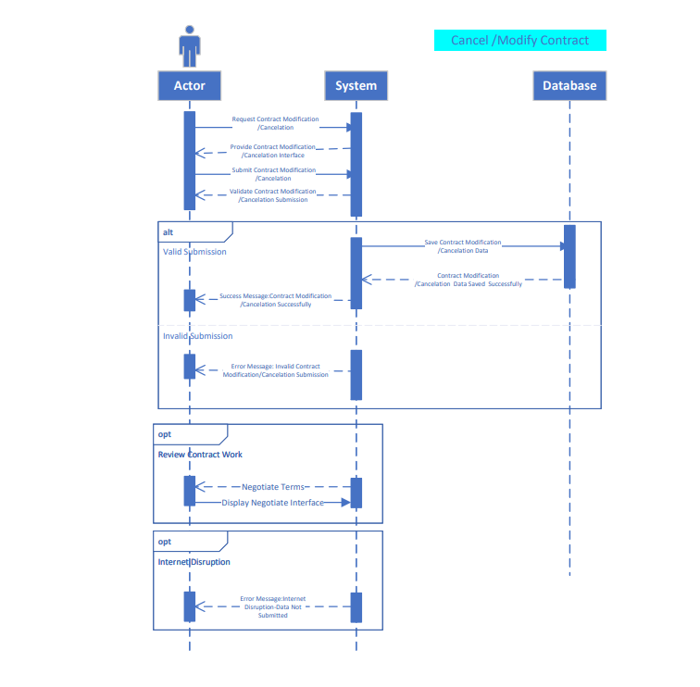
- Sequence diagram <Cancel/modify contract>

    - Sequence diagram 12<Contact Help Desk>
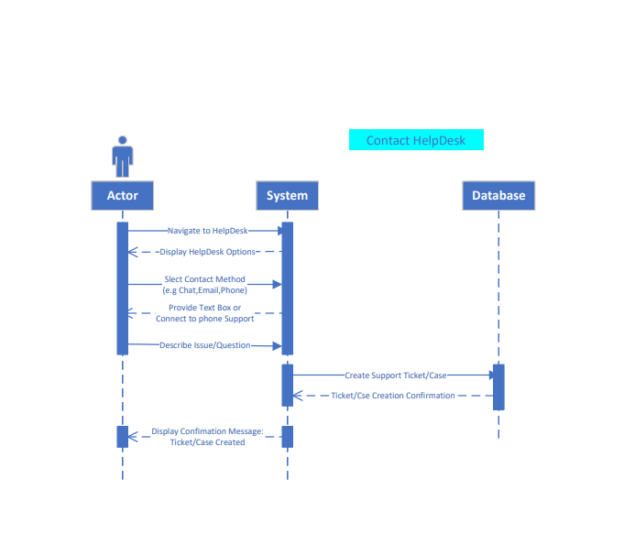
- Sequence diagram <Contact Help Desk>

    - Sequence diagram 13<Contact query parties>
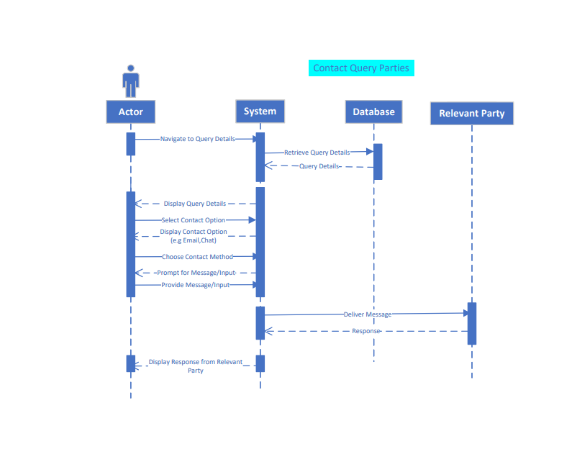
- Sequence diagram <Contact query parties>

    - Sequence diagram 14<Create group>
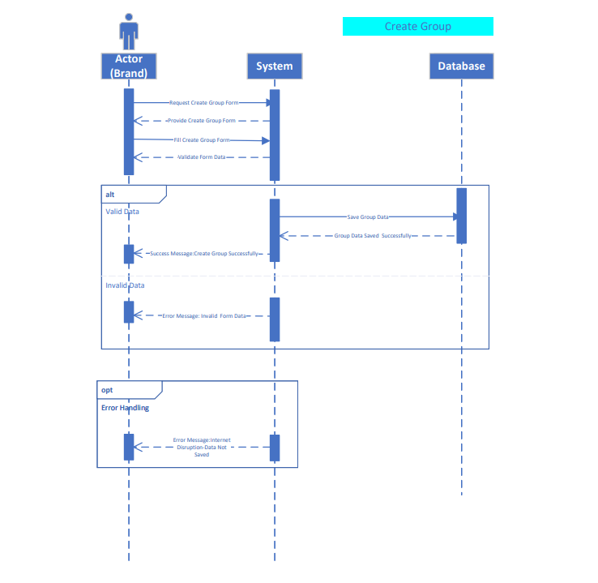
- Sequence diagram <Create group>

    - Sequence diagram 15<Delete/modify post/event>
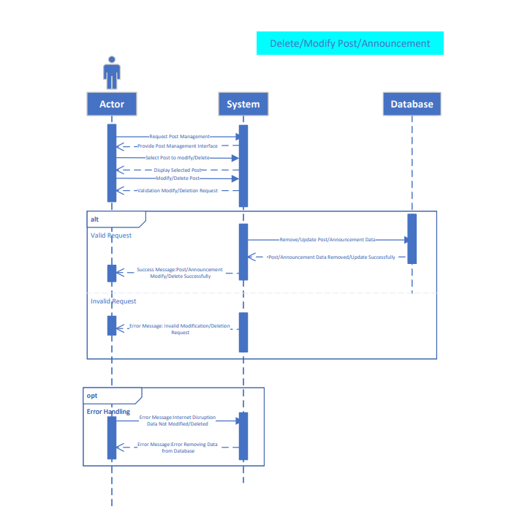
- Sequence diagram <Delete/modify post/event>

    - Sequence diagram 16<Delete/modify profile>
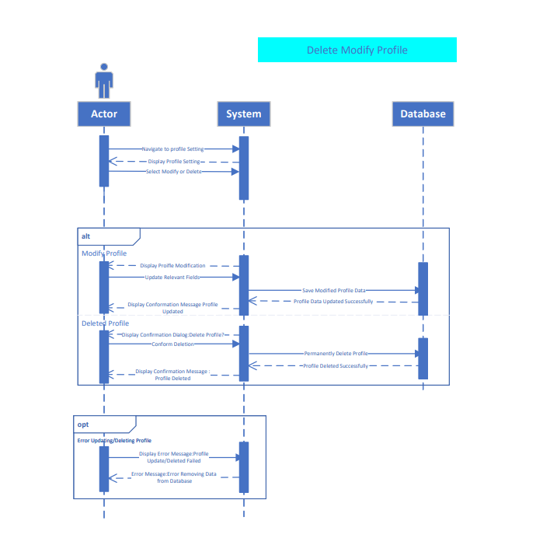
- Sequence diagram<Delete/modify profile>

    - Sequence diagram 17<Hire Professional>
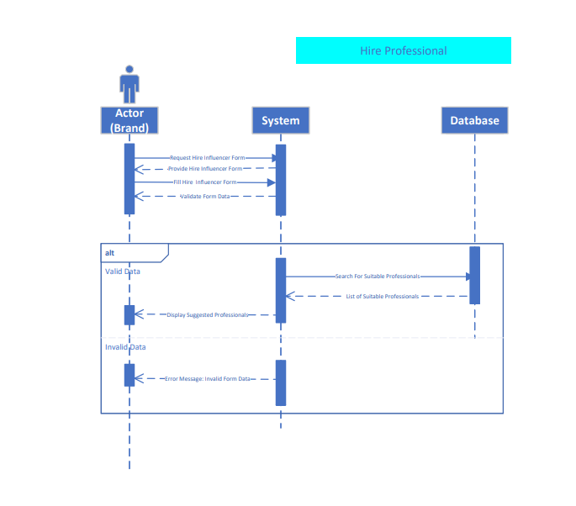
- Sequence diagram <Hire Professional>

    - Sequence diagram 18<Interact with post>
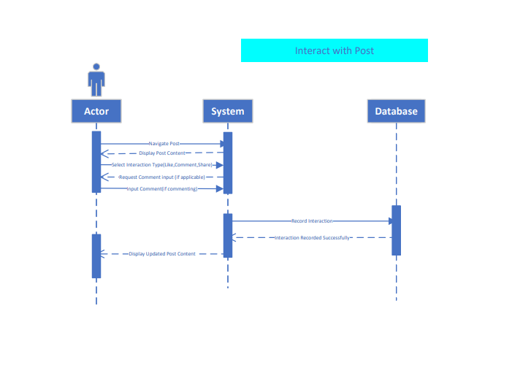
- Sequence diagram <Interact with post>

    - Sequence diagram 19<Join group>
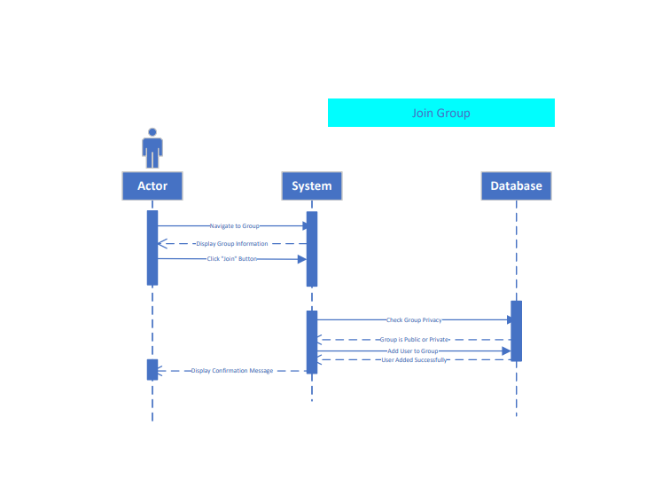
- Sequence diagram<Join group>

    - Sequence diagram 20<Delete/modify interactions>
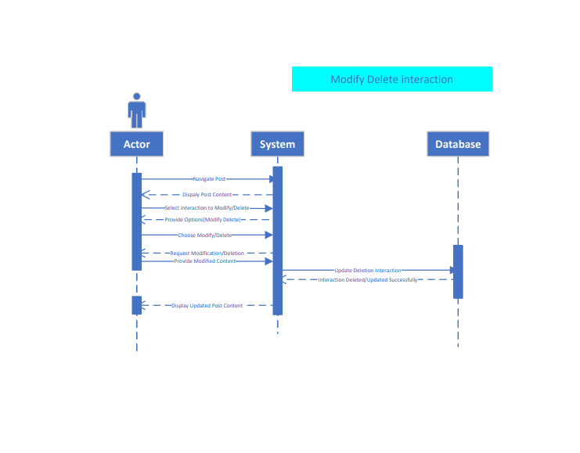
- Sequence diagram<Delete/modify interactions>

    - Sequence diagram 21<Offer Contract>

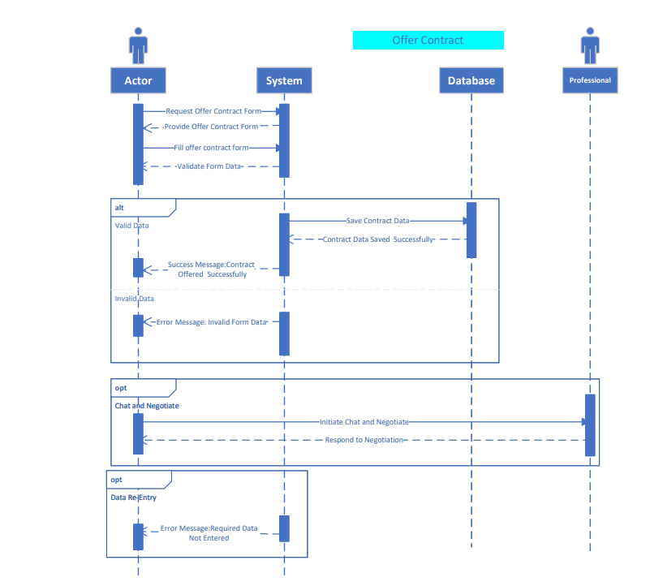

- Sequence diagram<Offer Contract>

    - Sequence diagram 22<View/submit deliverable of ongoing contract>

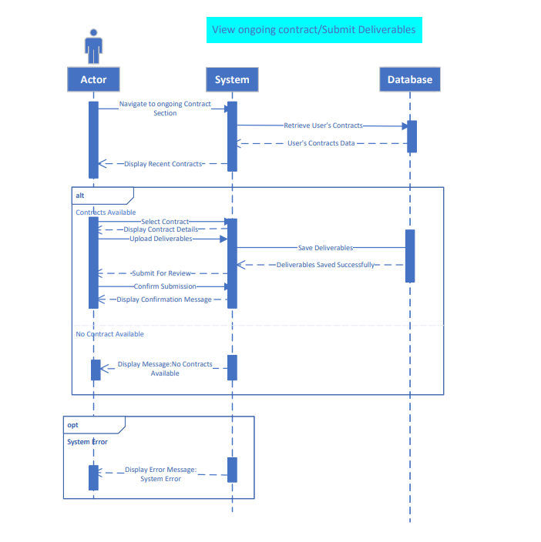

- Sequence diagram<View/submit deliverable of ongoing contract>

    - Sequence diagram 23<View/modify contract>

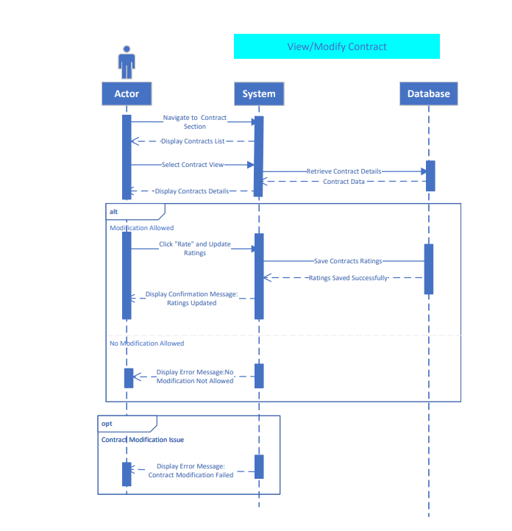
- Sequence diagram<View/modify contract>

    - Sequence diagram 24<View query>
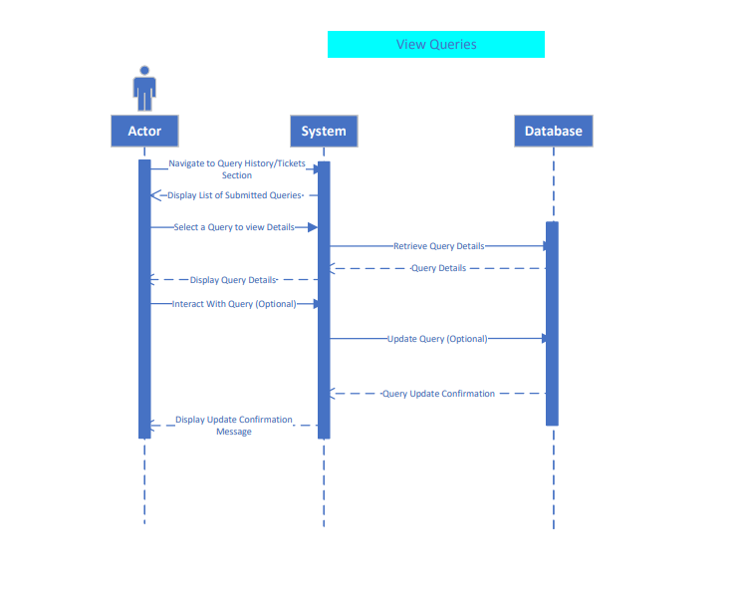
- Sequence diagram<View query>

    - Sequence diagram 25<Withdraw amount>
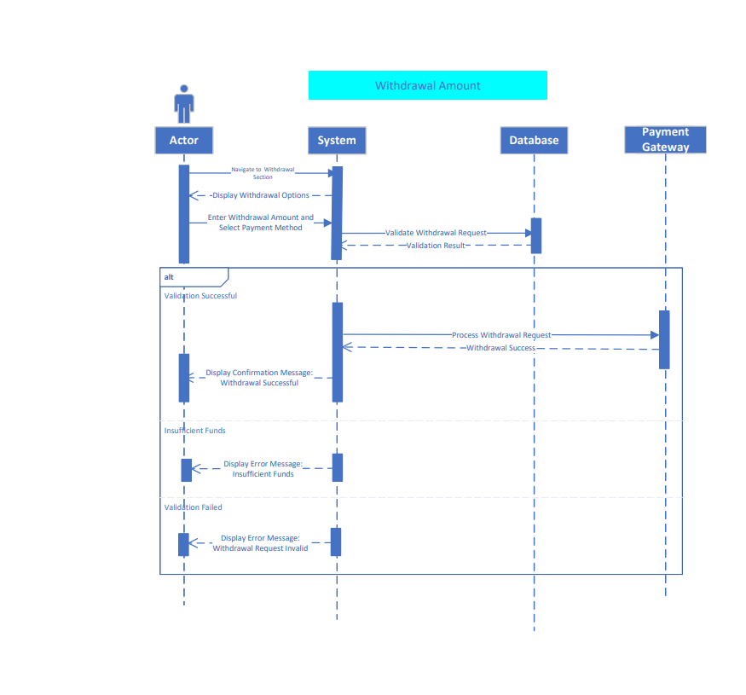
- Sequence diagram<Withdraw amount>

Software architecture

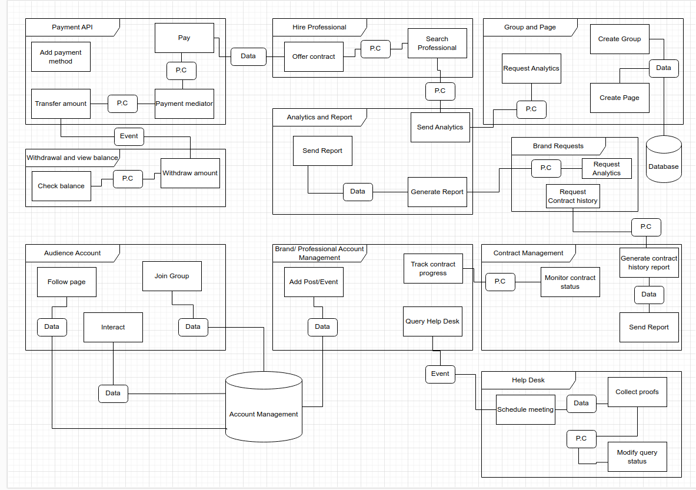
- Software architecture

Database diagram

- Database diagram

Network diagram (Gantt chart)

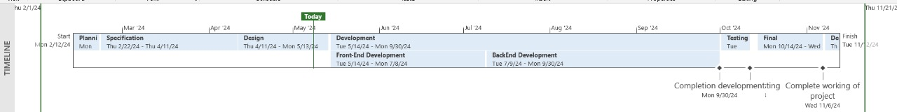
- Network diagram (Gantt chart part:01)
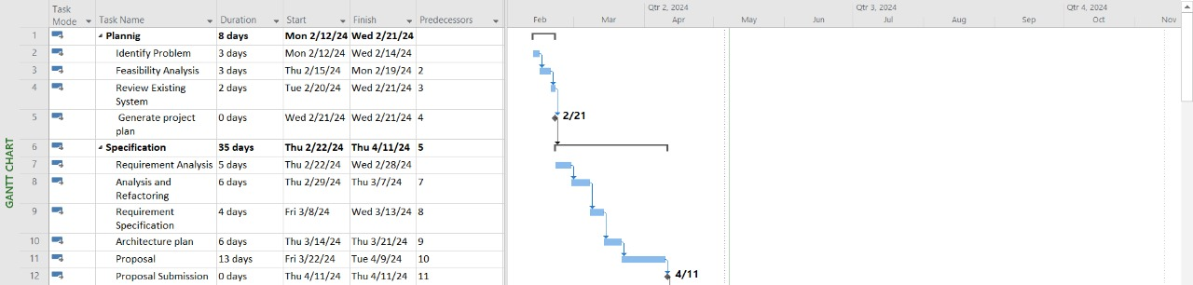
- Network diagram (Gantt chart part:02)
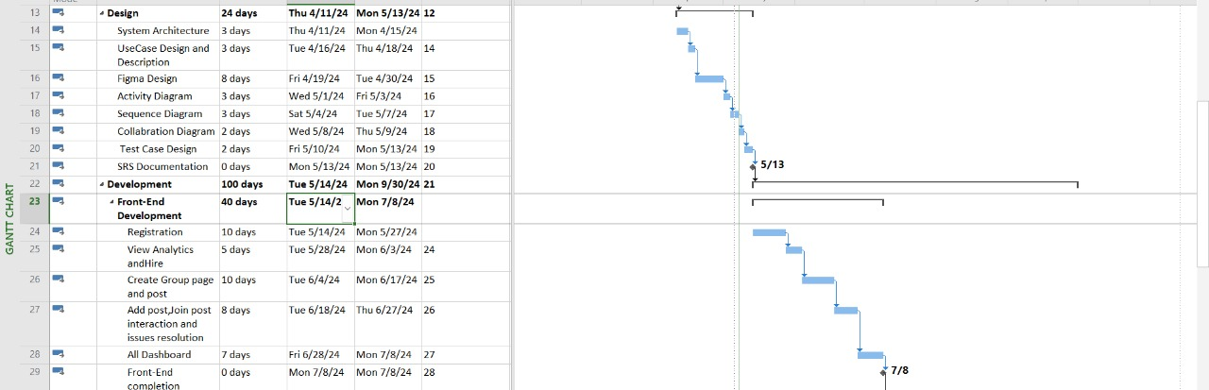
- Network diagram (Gantt chart part:3)
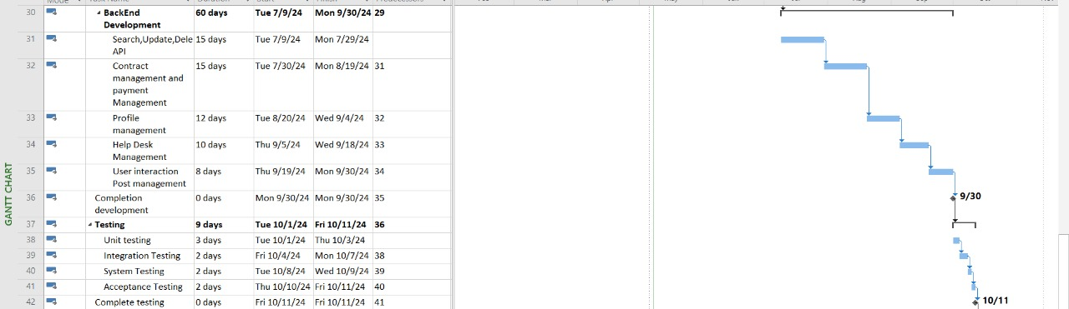
- Network diagram (Gantt chart part:4)
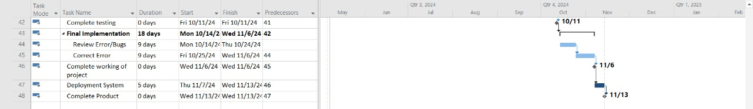
- Network diagram (Gantt chart part:5)

Class Diagram
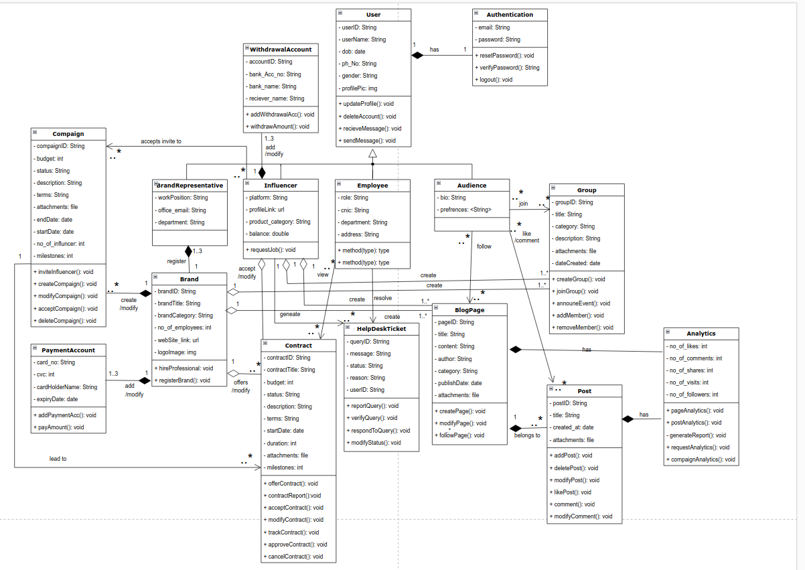

- Class Diagram

Collaboration Diagram

- Collaboration Diagram

Chapter 4: System Testing

Test cases:
    - Test case 01<Sign Up>
Test ID | Description
01 | This test case evaluates the validity of password length and the OTP verification process during sign-up. The password must be between 8 and 15 characters, and the email must be validated using an OTP sent to the user. The OTP must be validated within one minute; if it exceeds the time limit, the system should resend a new OTP.
Action |  | Data | Expected Output | Actual Output
- Password Length Less Than 8. |  | 13d | Invalid Password
- Password length exactly 8. |  | A09k01l2 | Valid password
- Password length between 8 and 15. |  | A56m0plh70 | Valid Password
- Password length greater than 15. |  | zz00mm99hh99ddhh7 | Invalid Password
- OTP entered in less than one minute. |  | 352627 | Valid
- OTP entered after one minute. |  | 093792 | Invalid
- OTP entered is wrong |  | 093030 | Invalid
Table 36 Test case<Sign Up>
    - Test case 02 <Login>
Test ID | Description
02 | This test case evaluates the login process, including scenarios of successful login, incorrect login credentials.
Action |  | Data | Expected Output | Actual Output
- The correct email and password. |  | influenceharbor@gmail.com  12345678 | Successful login
- The incorrect email or password. |  | influenceharbor@gmail.com  1234567 | Invalid email or password
Table 37 Test case <Login>
    - Test case 03<Add post>
Test ID | Description
03 | This test validates if the required field are filled or empty and makes sure that all are in correct format like the post name can be alpha numeric.
Action |  | Data | Expected Output | Actual Output
- The required fields are filled with data. |  |  | upload post
- The required field are unfilled. |  |  | One or more fields are empty
- The post name does not contain any special letters. |  | SVK0@1 | Invalid name
- The post name can be alpha numeric |  | SVK12 | Valid name
Table 38 Test case<Add post>
    - Test case 04<Modify post>
Test ID | Description
04 | This test enables the verify if the updated data entered is correct or not. If the data entered is not up to standard this should not update the database and asked to re-enter the correct data.
Action |  | Data | Expected Output | Actual Output
- The field can’t be empty which is required |  |  | Field can’t be empty
- The name contains special characters. |  | Ub95%H | Invalid name
- The update name is only alpha numeric. |  | Ub89 | Valid
Table 39 Test case<Modify post>
    - Test case 05<offer contract>
Test ID | Description
05 | This test case verifies if the user has entered the correct data and filled all the required fields. The budget and duration must be a number. Budget and duration must be greater than 0.
Action |  | Data | Expected Output | Actual Output
- All required field are filled |  |  | Notify professional
- One of the fields is not filled |  | budget | One or more field are missing
- The budget is less than 0. |  | -8 | Invalid
- The budget is equal to 0. |  | 0 | Invalid
- The budget is greater than 0. |  | 10 | Valid
- The duration is less than 0. |  | -8 | Invalid
- The duration is equal to 0. |  | 0 | Invalid
- The duration is greater than 0. |  | 10 | Valid
Table 40 Test case<offer contract>
    - Test case 06<modify contract>
Test ID | Description
06 | This test case verifies if the user has entered the correct data and filled all the required fields. The budget and duration must be a number. Budget and duration must be greater than 0.
Action |  | Data | Expected Output | Actual Output
- The filled field which are required can’t be removed. |  |  | required field can’t be empty.
- The budget modified with the number is less than 1. |  | 0 | Budget can’t be less than 1
- The budget modified is greater than 1. |  | 9 | Valid
Table 41 Test case <modify contract>
    - Test case 07<Add payment method>
Test ID | Description
07 | This test case evaluates the process of adding a new payment method, ensuring the necessary information is provided, validations are conducted, and errors are handled properly.
Action |  | Data | Expected Output | Actual Output
- Name is alpha string only. |  | John doe | Valid
- Name is alpha numeric. |  | John 23 | Invalid
- CVV is 4 digit. |  | 5666 | Invalid
- CVV is 3 digit. |  | 656 | Valid
- CVV is 2 digit |  | 98 | Invalid
- Expiry date is less than current date. |  | 02/24 | Invalid
- Expiry date is greater than current date. |  | 09/29 | Valid
- Expiry date is greater than current date but with over 10 years gap. |  | 12/2040 | Invalid
- Card number can only be numeric value. |  |  | Valid
- Card number is alpha numeric. |  | Alpha 0967 9790 | Invalid
- Card number length is less than . |  |  | Invalid
- Card number length is exactly . |  |  | Valid
- Card number length is greater than . |  |  | Invalid
Table 42 Test case <Add payment method>
    - Test case 08<submit deliverables>
Test ID | Description
08 | The deliverable must be submitted with the message of length greater than 5 words, and the file size for deliverables must be less than 5MB.
Action |  | Data | Expected Output | Actual Output
- The required field are empty. |  |  | One or more required fields are empty
- The file size is greater than 5MB. |  | 6 MB file | file size should be less than 5 MB
- The file size is less than 5MB |  | 2 MB file | uploaded
Table 43 Test case <submit deliverables>
    - Test case 09<Modify profile>
Test ID | Description
09 | This test enables the verify if the updated data entered is correct or not. If the data entered is not up to standard this should not update the database and asked to re-enter the correct data. The name can be only alpha string and dob between 1900-2016.
Action |  | Data | Expected Output | Actual Output
- The field can’t be empty which is required |  |  | Field can’t be empty
- The name contains special characters and number. |  | Ali%Saif | Invalid name
- The name is only alpha string. |  | Ali Saif | Valid
- The name is alpha numeric. |  | Ali 134 | Invalid
- The dob is less than 1900. |  | 1890 | Invalid
- The dob is greater than 1900. |  | 1989 | Valid
- The dob is greater than 2016. |  | 2020 | Invalid
Table 44 Test case<Modify profile>
    - Test case 10<rate contract>
Test ID | Description
10 | The rating can only be submitted if both the stars and comment is added. The comment length can’t be less than 20 words. The stars can’t be less than 1.
Action |  | Data | Expected Output | Actual Output
- The selected star rating is less than 1. |  | 0 selected | rating is required to be selected.
- The selected star rating is greater than 1. |  | 2 | valid
- The message length is less than 20. |  | Good | Invalid
- The message length is exactly 20. |  | I loved working with him | Valid
- The message length is greater than 20. |  | I loved working with him, hoping for future projects. | Valid
Table 45 Test case<rate contract>
    - Test case 11<withdraw amount>
Test ID | Description
11 | The withdraw amount can’t be less than 10 USD and greater than 10,000 USD.
Action |  | Data | Expected Output | Actual Output
- The withdraw amount is less than 10 USD. |  | 8 | Invalid
- The withdraw amount is greater than 10 USD and less than 10,000 USD. |  | 900 | Valid
- The withdraw amount is greater than 10,000 USD. |  | 10,100 | Invalid
Table 46 Test case <withdraw amount>
    - Test case 12<modify query status>
Test ID | Description
12 | The query status can be pending, initiated or completed. The status can be changed to initiated if it is in pending state. The completed can be marked only if it is in initiated status. The pending status can never be assigned.
Action |  | Data | Expected Output | Actual Output
- The status is changed to completed from pending status. |  | completed | Invalid
- The status is changed to initiated from pending status. |  | initiated | valid
- The status is changed to completed from initiated status. |  | completed | valid
Table 47 Test case<modify query status>
    - Test case 13<respond to query>
Test ID | Description
13 | To respond to query message and proof attachment must be attached. The message size can’t be less than 20 characters. The size of attachment must be less than 2 MB.
Action |  | Data | Expected Output | Actual Output
- The message length is less than 20 characters. |  | Good | Invalid
- The message length is exactly 20. |  | I loved working with you | valid
- The message length greater than 20 characters. |  | I loved working with him. I hope won’t happen again. | Valid
- The file size is less than 2 MB. |  | 1 MB file | Valid
- The file size is greater than 2 MB. |  | 3 MB file | Invalid
- The file size is 2 MB. |  | 2 MB file | Invalid
Table 48 Test case <respond to query>
    - Test case 14<Interact with post>
Test ID | Description
14 | The comment length must be 3 character or greater.
Action |  | Data | Expected Output | Actual Output
- The comment length is less than 3 character. |  | oo | Invalid
- The comment length is 3 character. |  | uff | Valid
- The comment length is greater than 3 character. |  | Fantastic | Valid
Table 49 Test case<Interact with post>
    - Test case 15<Modify interaction>
Test ID | Description
15 | The comment length must be 3 character or greater, can’t be empty when published.
Action |  | Data | Expected Output | Actual Output
- The comment length is less than 3 character. |  | oo | Invalid
- The comment length is 3 character. |  | uff | Valid
- The comment length is greater than 3 character. |  | Fantastic | Valid
- The comment is updated with two character string. |  | um | Invalid
Table 50 Test case<Modify interaction>

Unit Testing:
Unit testing revealed discrepancies in the functionality of certain features, such as profile management and communication tools. Issues like incomplete profile setups and inconsistent data validation required meticulous debugging to ensure seamless user experience.

Integration Testing:
Integrating various modules posed challenges in ensuring smooth communication between different components of the platform. Compatibility issues between the user interface and back-end systems required extensive testing and debugging to ensure cohesive integration.
  - Acceptance Testing:
Acceptance testing uncovered usability concerns and performance bottlenecks, especially in high-traffic scenarios. Feedback from users highlighted the need for optimization in page loading times and navigation pathways to enhance overall user satisfaction.

Chapter 5: Conclusion

Problems faced and lessons learned:
    - Data Integrity: Maintaining data integrity across different modules proved to be a significant challenge. Ensuring consistency in user profiles, campaign data, and communication logs required robust data validation protocols and error handling mechanisms.
    - User Adoption: Encouraging user adoption and engagement posed challenges, particularly in attracting influencers and retaining active users. Strategies such as targeted marketing campaigns and incentive referral programs were explored to overcome this hurdle.
    - Regulatory Compliance: Navigating regulatory compliance issues, particularly concerning data privacy and advertising regulations, required close collaboration with legal experts and continuous monitoring of relevant legislation to ensure adherence.

Project summary:
Influence Harbor represents a significant step forward in revolutionizing the influencer marketing landscape, providing a comprehensive platform for brands, influencers, and users to connect, collaborate, and engage. By leveraging machine learning algorithms, the platform streamlines the process of influencer selection, ensuring optimal matches for brands' marketing campaigns. The creation of blog pages and chat groups fosters transparent communication between brands and users, facilitating valuable feedback and insights. Despite encountering challenges during development and testing, Influence Harbor stands poised to reshape the dynamics of influencer marketing, empowering businesses to maximize their outreach and impact.

Future work:
    - Expanded Features: Introducing new features such as live streaming capabilities, interactive polls, and augmented reality experiences to enrich user interactions and drive engagement.
    - Global Expansion: Scaling the platform to cater to a broader audience across different geographic regions, taking into account diverse cultural preferences and market dynamics.
    - Partnerships and Collaborations: Forging strategic partnerships with industry stakeholders, including marketing agencies, social media platforms, and regulatory bodies, to foster innovation and drive industry-wide adoption of best practices.

References:

References to any book, journal paper or website should properly be acknowledged, For example.

- Lyda M.S. Lau, Jayne Curson, Richard Drew, Peter Dew and Christine Leigh, (1999), Use Of VSP Resource Rooms to Support Group Work in a Learning Environment, ACM 99, pp-2. (Journal paper example)
- Hideyuki Nakanishi, Chikara Yoshida, Toshikazu Nishmora and Turu Ishada, (1996), FreeWalk: Supporting Casual Meetings in a Network, pp 308-314 (paper on web)
  - http://www.acm.org/pubs/articles/proceedings/cscw/240080/p308-nakanishi.pdf
- Ali Behforooz & Frederick J.Hudson, (1996), Software Engineering Fundamentals, Oxford University Press. Chapter 8, pp255-235. (book reference example)
- http://www.bt.com/bttj/archive.htm (web site)

APPENDICES

- ANY OTHER SUPPORTING SCHEDULES or DOCUMENTS

Appendix A

Include here the 1st page of Turnitin Report
Every supervisor has his/her own Turnitin account. If not then the supervisors are requested to get the account from Library as soon as possible.

